CURRICULUM VITAE

APURBA NATH
Present Address | Permanent Address
Apurba nath  VILL :- Katwa  P.O. :- Katwa  P. S. :- Katwa  Dist. :- Barddhaman  State :-West Bengal  Pin :-713130 | Apurba Nath  VILL :- Katwa  P.O. :- Katwa  P. S. :- Katwa  Dist. :- Barddhaman  State :-West Bengal  Pin :-713130

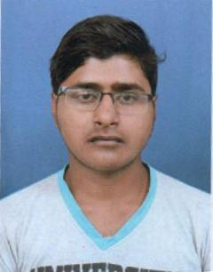

Personal profile:

Name : Apurba Nath
E-mail :apurban1988@gmail.com
Contact No : +91-6294398477
Date of Birth : 20/04/1988
Father's Name : Mahadev Nath
Sex : Male
Caste :-General
Nationality : Indian
State : West Bengal
- Academic qualifications:
Name of the examination | School/College | Board | Year | Aggregate
Madhyamik | Katwa Sri RAMKRISHNA  Vidyapit | West Bengal Board of Secondary Education | 2006 | 42%
H.S | Katwa Sri RAMKRISHNA  Vidyapit | West Bengal Council of Higher Secondary Education | 2009 | 40%
B.A | Cmj University | Meghalaya | 2012 | 71.66%

- Strengths:
Personal strengths : Hard working ability with my full effort and responsibility,
I want to achieve better goal in my professional life, so kindly give me one chance to prove myself.

- Job Experience:
: Bharat Financial Inclusion LTD ( 2010 to 2016)
: HDFC BANK LTD ( 2016 to 2017)
: BAJAJ FINSERV LIMITED (2017 Jun to 2017 Nov)

- Other Qualification :
:

- Additional Information:
Languages known : Bengali, English, Hindi.
- Declarations:
I hereby declare that the above mentioned information is correct to the best of my knowledge and I bear the responsibility for the correctness of the above mentioned particulars.

Date :

Place:
.
Signature of the Applicant

