RESUME

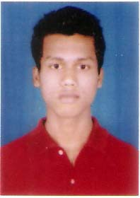**NAME**  : Richard Luke Pereira

**ADDRESS** : Hi –home, Sonamukhi Jholi

Ward no. 29, P.O. Hijli,

Kharagpur, Midnapore(W)

West Bengal – 721306

**CONTACT** : Mob – 7029144273

8001988677

ID – [Pereirarichard777@gmail.com](mailto:Pereirarichard777@gmail.com)

* **Career objective:**

Given a chance would surely implement my knowledge, skills and experiences for the development of the firm. And also open to learning new skills that would be in accordance for the betterment of the firm. Enthusiastic, loyal and accomplishment oriented mindset towards the specific task allotted.

* **Academic Qualification:**
* Graduation : B.com – 1st division [IGNOU]- 2016-2019
* Xii : Arts -2nd division [NIOS]- 2011-2013
* X : 2nd – division [NIOS] -2009-2010
* **Professional Qualification**:
* Tally ERP9 : Certificate in Financial Accounting System CFAS & DFAS

[DIPLOMA] -2016 -17

* M.S Office : Word, Power Point &Excel – 2016 -17
* ITI : Hardware & Advanced Networking on computer

[DIPLOMA] -2013 -15

* **Personal Details:**

Date of birth : 18th September 1993

Father name : Mr. Ronnie Simon Pereira

Mother name : Mrs. Cheryl Ann Pereira

Religion : Christian

Nationality : Indian

Caste : General

Sex : Male

Martial status : Unmarried

Hobbies : Reading & Exercising (Gymnasium)

Language

Known : English, Hindi & Bengali

* Declaration :

The following informative details imprinted above are true and correct to the best of my knowledge in accordance to the relevant document furnished below. Thank you for your precious movement.

**Date :**

**Place:** (**RICHARD LUKE PEREIRA**)