**ARUP KUMAR CHOWDHURY** Mob : 7004603787, 8235394264 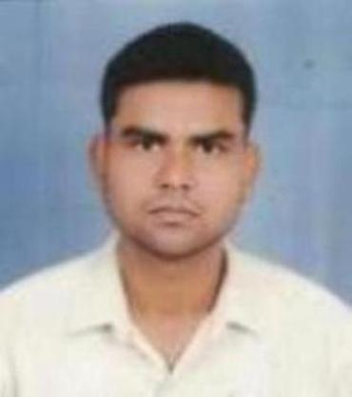 E-mail : [arupchowdhury885@gmail.com](mailto:arupchowdhury885@gmail.com) **WORK EXPERIENCE IN COMPANYS** Company Name 1) Kutumbh Care Pvt Ltd. 2) SYSNET GLOBAL TECHNOLOGIES PVT LTD 3) TECH ELECON PVT LTD 4) CMS IT SERVICES Stile Working From October 2020

**OVERALL WORK EXPERIENCE IN FIELD 6 YEARS.** **EDUCATIONAL QUALIFICATION** 1) 10TH From JHARKHAND ACADEMIC COUNCIL, RANCHI 2) 12TH From JHARKHAND ACADEMIC COUNCIL, RANCHI

**SYNOPSIS** DIPLOMA IN HARDWARE AND NETWORKING.

I am certified by INDIAN INSTITUTE OF HARDWARE TECHNOLOGY. Hardware and Networking (ACHNP) Course.

**TECHNICAL SKILLS** 1) Troubleshoot All Desktop/laptop Hardware & Software Related Problems. 2) Installing Operating System Such As Windows Xp,7,8,8.1,10 On Desktop/ laptop. 3) Installing of Software Like Corporate Client,Quick Antivirus, Ms Office Package. 4) Troubleshooting Network Related Issues. 5) Installing Of LAN – Based Network. 6) Having Sound Communication Skill & Capable Of Handling Tasks Indepently. 7) Troubleshoot & Repair All Printers Like Inkjet/Lesarjet/DMP Hardware & Software Related problems.

**PERSONAL DETAILS** Father Name : Sagar Chowdhury Date Of Birth : 10 Feb 1993 Marital Status : Married Language Proficiency : English,Hindi,Bengla Nationality : Indian Sex : Male **CONTACT INFORMATION** Permanent Address Current Address Village – Kastora Village – Kastora Post – Sadhana rangamati Post – Sadhana rangamati P.S – Saltora P.S – Saltora Pincode - 722143 Pincode – 722143 Dist – Bankura Dist – Bankura Stat – West Bengal Stat – West Bengal **HOBBIES** 1) Playing Chess. 2) Listening Music. 3) Reading Computer Related Books. All The Information Provided By Me In This Application is Correct And I Have Not Knowingly Submitted Any Information That Would Create Any Problem On My Part. Place : Bankura (Arup Kumar Chowdhury)