CURRICULUAM VITAE

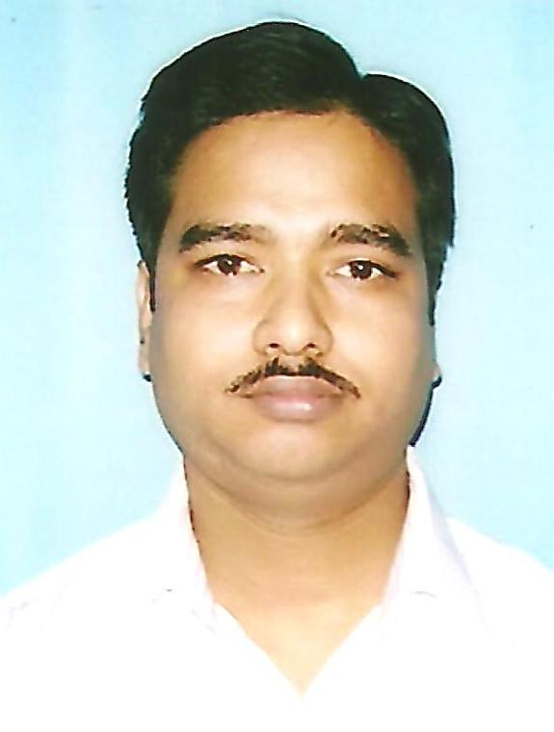

AMIT KUMAR SHIL

Email: amit_k100in@yahoo.co.in

Phone: 09433335616, amitshil.1977@gmail.com

Career Goal

To provide service in the field of Operations / Business Development /Sales/Relationship management/Marketing of an organization by my acquired knowledge, initiative, sincerity and hard work for the business growth.

Career Snapshot

- 16 years of Rich experience in the areas of Sales, Business Development, Team Handling, Marketing & Relationship Management in the field of Loan sector (Gold Loan, vehicle loan, SME loan) and Insurance (Both Life and General) .
- Overall Work experience is more than 16 years.
- A proven manager with ability for strategic planning and sustaining business.
- Identifying prospective clients, generating business from new Customer and developing them to achieve consistent profitability.
Responsible for dealing with external and internal auditors and inspections and compliance
- Supervising Key Areas including Marketing, Business Development, Team Management more than 60 employee reporting me, Administration, Cost Management, Revenue Generation.

- for Developing relationships with key decision-makers in target organizations for business development.

--------------------------------------------------------------------------------------------------------------

Education

Professional Qualification: Master of Business Administration (MBA) from Kalyani University (WB) in 2001 (September).

Academic Qualification: B. Com (Hons) from Calcutta University (WB) in 1998.

Computer Skills

Operating System : MS-DOS.

Package : MS-Office

Personal Details

Fathers Name | Late Amulya Ratan Shil
Date Of Birth | 01-01-1976
Nationality | Indian
Marital Status  Passport No | Married  E 8313037<3IND7601015M 1411074-4
Permanent Address | Halisahar Khasbati  Post: Hazinagar  Dist: 24 Parganas (North)  Pin-743135, West Bengal

Extra-Curricular Activities:

Inter School level Cricket

School level Athletics

Second prize win in state level recitation competition.

Experience:
Currently working with India Infoline Finance Ltd as Territory Manager

Job profile:

Team Handling (Looking 12 Branches and more than 70

Employee)

2) Employee productivity and Target achievement

3) Looking Gold Loan (Handling more than 100cr portfolios)

4) Looking Cross sell SME loan, Health Insurance and Demat.

5) New area development for opening new Branch

6) Monitoring Interest collection

8) Looking all audit issue internal as well as external

10) Employee engagement and training

11) HNI Meet

Branch Manager in Muthoot Finance Ltd.

From 2012 March to 2017 May at Kaliyaganj (Uttar Dinajpur) and Kalyani, West Bengal.

Job Profile: -

1) Team Handling (both branch and Sales)

2) All Branch Administration

3) Mortgage (Gold loan)

4) Field verification for high value Loan

5) Monitoring Interest collection, Handling collection Team

6) Loan against NCD/Share

7) Insurance (Life) and Gen INS (motor, health and Home)

8) Recovery of NPA A/C
9) HNI customer meet (Direct Marketing)

2) ABM-Sales in Peerless General Finance & Investment Co.Ltd. From 2004 July to 2009-Executive - Marketing, ABM-Sales from 2009 June to 2012 February at Balurghat, Dakshin Dinajpur

Job Profile: - 1) Channel development (Savings-RNBC, Insurance & MF)

2) Team handling

3) New Market development.

4) Training and Development (Total District net work)

5) Event Management

6) Collections.

I have achieved Bangkok tour 2009-2010 for life Insurance Business.

3) J. Executive (Operations) of Sundram Finance Limited. Kolkata .

From 2003 (May) to 2004 (June).

Job Profile: - 1) Filed investigation.

Three Wheeler Section and 4 Wheeler section (Loan Dept)

2) Collection.

3) Cash handling.

Ad-Sales Executive of Ad-Advantage Innovative Media Pvt. Ltd. (Electronic Media) 14 months (Delhi).2002 (March) to 2003 (May)

Job Profile: - 1) Create new customer.

2) Market Promotion (Road show & fair).

3) Collections.

Date:

Place: Kolkata (Amit Kumar Shil)

