|  |  |
| --- | --- |
|  |  |
|  | Abhinaba Dutta |

|  |
| --- |
| CURRICULUM VIATAE |
|  |

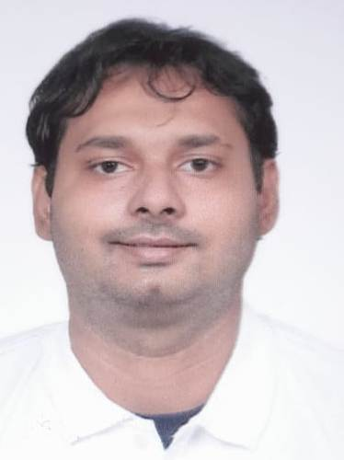

Name: *ABHINABA DUTTA*

Address – 19/3 Nawab Abdul Latif st. flat- D/2 Belgharia,Kolkata-700056

Email Id: [duttaabhinaba2016@gmail.com](mailto:duttaabhinaba2016@gmail.com)

Ph no.- 8697584514 , 9123883285

# CAREER OBJECTIVE

Being a candidate to build my career in your organization where I can get opportunities to prove my qualities by all challenges.

# ACADEMIC QUALIFICATION

CITY COLLEGE OF COMMERCE ,UNIVERSITY OF CALCUTTA

B.COM (HONOURS IN FINANCE AND ACCOUNTS) - 50%, Year- 2013-2016

BELGHARIA HIGH SCHOOL,WEST BENGAL BOARD

HIGHEIR SECEONDARY(10+2) - 68.50%, Year-2013

BELGHARIA HIGH SCHOOL,WEST BENGAL BOARD

MADHYAMIK - 60%, YEAR- 2011

# COMPUTER SKILLS

* TALLY ERP9
* ADVANCE EXCEL
* MS WORD
* FA FACT
* EX NEXT GENERATION
* ORACLE

EXPERIENCE

|  |  |  |  |
| --- | --- | --- | --- |
|  |  | |  |
| *BANDYOPADHYAY & CO(CA FIRM)-*SEPTEMBER’20 TO FEBRUARY’21  ACCOUNTS EXECUTIVE  PURCHASE BILL ENTRY,SALES BILL ENTRY, BRS, BALANCE SHEET, INCOME & EXPENDITURE,TRIAL BALANCE.  ASSOCIATED PNEUMATIC INDUSTRY PVT LTD- MARCH’21 TO OCTOBER’21  ACCOUNTANT  STATE GST AND CENTRAL GST ENTRY, BILL ENTRY AND BILL PROCESSING,FINAL ACCOUNTS,MAINTAING ALL TYPE OF SYSTEM DATA,STOCK MAINTAIN(UNDER FIFO AND LIFO METHOD) | | PODS E-TAXATION – NOVEMBER’21 TO OCTOBER’22  SENIOR EXECUTIVE  ALL TYPE OF EPF WORK, ESIC WORK, TRIAL BALANCE, GST WORK(PURCHASE,SALES)  *ICICI BANK(IPROCESS)* – NOVEMBER’22 – ATPRESENT  SENIOR ASSOCIATE  ALL TYPE OF KYC CHECKING,INVOICE,INSURANCE,RC,ROC, UPDATION,LOAN FILE PROCESSING, FILE DISPATCH,(TWO WHEELER,EDUCATION,COMMERCIAL BUSINESS),ALL TYPE OF WORKS IN OPERATION. | |

# STRENGTH

* Good typing speed(>20 wpm)
* Good communication skill( comfort in English,hindi,Bengali)
* Positive attitude

# PERSONAL PROFILE

* + **Father’s Name: ALOKE NATH DUTTA**
  + **Date of birth: 22/10/1994**
  + **Gender : male**
  + **Martial status: unmarried**
  + **Language known: Bengali, Hindi, English**
  + **Nationality: Indian**

**EXTRA CURRICULLAM:**

AT PRESENT PLAYING BENGAL SHOOTING (10 METER AIR PISTOL)

# DECLARATION:

I solemnly declare that all the above information is correct to the best of my knowledge and belief.

Place: kolkata

(ABHINABA DUTTA)