**CURRICULUM VITAE**

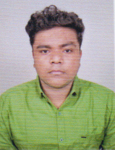

**AKASH DAS**

S/O-Tapan Das, Vill.-Thakurchak, P.O.-Balichak, P.S.-Debra

Dist.-PaschimMedinipur, Pin.-721124

State-W.B.

Mob.:+91 9635677456

Email.:[rajadas8500@gmail.com](mailto:rajadas8500@gmail.com)

**OBJECRIVE**

**To work with those challenging projects, which will contribute towards the achievement of the**

**company and also help me in enhancing my own skill sets to keep in pace with growing industry.**

**ACADEMIC QUALIFICATION :**

|  |  |  |  |  |  |
| --- | --- | --- | --- | --- | --- |
| **NAME OF**  **EXAMINATION** | **BOARD** | **INSTITUTE** | **YEAR OF PASSING** | **% OF**  **MARKS** | **DIVISION** |
| MADHYAMIK | W.B.B.S.E | Antala Sitala  High School | 2015 | 47.71 | 2nd |
| HIGHER SECONDARY | W.B.C.H.S.E | Balichak B.H  Instituiton | 2017 | 56.00 | 2nd |
| B.Com(Hons.)  (Accountancy) | C.C.S.U | C.C.S.U. (MEERUT) | 2020 | 64.50 | 1st |

**PROFESSIONAL QUALIFICATION**

Basic knowledge of Computer

**EXPERIENCE**

* **9** Month in Electicrun As a Sale’s Exicutive.
* **8 Month in Reliance Jio Mart As a Horeca Devlopment Associate.**

**PERSONAL DETAILS**

**DATE OF BIRTH : 28-01-2000**

**NATIONALITY : I**ndian

**SEX :** Male

**MARITAL STATUS :** Single

**RELIGION :** Hindu

**LANGUAGE KNOWN :** English, Hindi, Bengali.

**COMPUTER KNOWLEDGE :** CITA

**DECLARATION**

I do here by Declare that the above statement are true and correct to the best of my knowledge and belief. In the event of any information found false / incorrect my candidate may be cancelled without any notice.

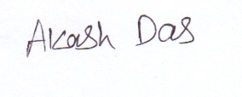

Place : Balichak

Date : (Signature Candidate)