*RESUME*

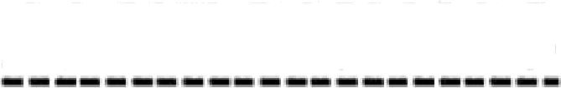

AMIT BISWAS

**ADDRESS :**-_VILL-DINGAMANIK, P.0-SEKATI, P.S-GAIGHATA, DIST-

NORTH 24 PARGANAS, STATE-WEST BENGAL, PIN-743245

## **CONTACT DETAILS**

PHONENUMBER - 6294675002

EMAIL ID— biswasamit405@gmail.com

**PERSONAL INFORMATION**;

NAME- AMIT BISWAS

FATHER NAME- AJITBISWAS

DATE OF BIRTH- 08/07/1996

CAST- O.B.C

MARITAL STATUS- UNMARRIED

GENDER-MALE RELIGION-HINDUISM NATIONALITY- INDIAN

LANGUAGE KNOWN- BENGALI,HINDI,ENGLISH

# **CAREER OBJECTIVE**

TO SEEK A DYNAMIC AND CHALLENGING CAREER AN ORGANIZATION STRIVES FOR EXCELLENCE WITH MY KNOWLEDGE AND TEAM EFFORT WHILE MAKING POSITIVE CONTRIBUTION TO PROMOTE THE INDIVIDUAL OPPORTUNITY AND PROFESSIONAL GROWTH.

# **ACADMIC QUALIFICATION**

|  |  |  |  |  |
| --- | --- | --- | --- | --- |
| SR.NO | CLASS | BOARD/UNIVERSITY | YEAR | DIVISION/PERCENTAGE |
| y | 10TH | W.B.B.S.E | 2012 | 39.1% |
| 2 | H.S | W.B.C.H.S.E | 2014 | 41.4% |
| y | B.A | K.S.0.U | 2017 | 64.1% |

**EXTRA QUALIFICATION**

DIPLOMA IN COMPUTER APPLICATION (A.C.I.T.A)

## YEAR-2013, PARCENTAGE-74%

**EXPERIENCE**- PRAGTI MARINE SERVICE P.V.T L.T.D OILLER

ENGINE DEPARTMENT. 02/02/2018 TO 15/08/2018.

# **LOAN** **0FFICER INDUSIND RETAII BHARAT FINAECIAL INCLUSI0N LIMITED- /01/10/2020 TO TILL DATE.**

# **DECLARATION**

I DO HERE BY DECLARE THAT THE STAT TO THE BEST OF MY KNOWLEDGE AND BELIEFEMENTS MADE IN THIS DOCUMENT ARE TRUE*.*

# DATE

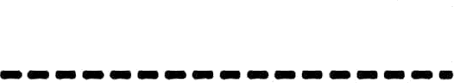

SIGNATURE