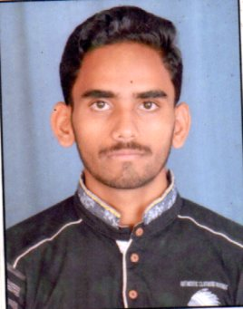
CURRICULUM VITAE
Bikki sharma

CAREER OBJECTIVE: To Find A Place For The Enhancement Of My Knowledge And Experience.
.

CONTACT INFORMATION:
Address | Permanent | 3/8 Ramkrishna Sarani, Rania North, Bansdroni, Kolkata-700070
Address | Present | 3/8 Ramkrishna Sarani, Rania North, Bansdroni, Kolkata-700070
Contact No | +91 8585807505 / 7278303050
E-mail ID | bikkisharma28@gmail.com

EDUCATIONAL QUALIFICATION:
EXAMINATION | INSTITUTION | BOARD &  UNIVERSITY | YEAR OF PASSING | MARKS (%)
MADHYAMIK | MAHESH BANGA VIDYALAYA | W.B.B.S.E | 2015 | 55%
HIGHER SECONDARY | KALIGHAT HIGH SCHOOL | W.B.C.H.S.E | 2017 | 74%
GRADUATION (Bachelor In Commerce) | SYAMAPRASAD COLLEGE | CALCUTTA UNIVERSITY | 2020 | 71%

COMPUTER SKILLS:
COURSES DONE | Computer Application, Operating System, Tally ERP9, MS office, MS excel……………..

PERSONAL PROFILE:
Father’s Name | RANJAN SHARMA
Date of Birth | 28TH JULY 1997
Nationality | Indian
Sex | Male
Martial status | Unmarried

STRENGTHS:
- Deep-rooted values of Honesty, Sincerity, Punctuality and Discipline.
- Comprehensive Problem Solving & Convincing Abilities.
- Determined to make the most of Opportunities.
- Optimistic in the Ups and Downs of Life.
- Confident in Abilities and Hard Work.
- Willingness to Learn.

WORK EXEPERIENCE

- Work as a Salesman in Airtel Company for 1 year.
- Working in BANK OF BARODA CSP POINT as SUB BC Agent SINCE 2 years.

INTEREST : Accounting & Financing, online surfing,etc.

HOBBIES : Dancing, Sports and Social Activity.

LANGUAGES KNOWN : Hindi, English & Bengali

DECLARATION:

I hereby declare that the above information is true and that to the best of my belief and knowledge.

PLACE- KOLKATA DATE- (Signature)

