**CURRICULLAM VITEA**

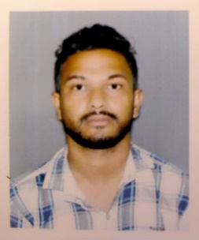

**NAME : TARAK GHOSH**

**FATHER’S NAME : LAKSHMAN GHOSH**

**DATE OF BIRTH : 02/06/1993**

**PERMAMENT ADDRESS : VILL-JEWDHARA, P:O+P.S -KALNA**

**DIST-PURBA BARDDHAMAN, PIN-713409**

**CONTACT NUMBERS : 9564928099**

**SEX : MALE**

**MARITAL STATUS : UNMARRIED**

**NATIONALITY : INDIAN**

**RELIGION : HINDU**

**LANGUAGES KNOWN : BENGALI,HINDI,ENGLISH**

**CATEGORY : GENERAL**

**EDUCATION QUALIFICATION :**

|  |  |  |  |
| --- | --- | --- | --- |
| **NAME OF EXAM** | **BOARD/UNIVERSITY** | **YEAR OF PASSING** | **MARKS IN PERCENTAGE** |
| **MADHYAMIK** | **WBBSE** | **2009** | **36.87%** |
| **HIGHER SECONDARY** | **WBCHSE** | **2011** | **50%** |
| **B.A** | **BURDWAN UNIVERSITY** | **2014** | **35.25%** |

**EXTRA QUALIFICATION :- COMPUTER WEBDESIGN COURES ( IT SMART )**

**WORK EXPERIENCE:- HAVE2 YEARS OF EXPERIENCE IN A MICROFINANCE COMPANY (MSG NIDHI LIMITED) .**

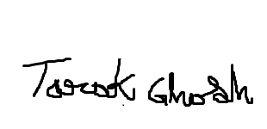**\*NOW WORKING IN HDFC BANK (UP TO 1 YEARS 8 MONTH’ RUNNING)**

**DATE: _______________________**

**PLACE: KALNA**  SIGNATURE OF THE CANDIDATE