**CURRICULAM VITAE**

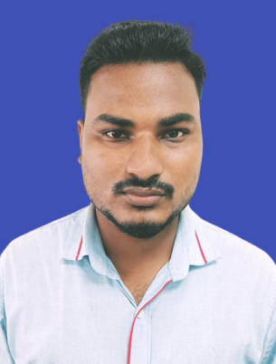

**BISWAJIT SAHOO**

S/o – Dasarathi Sahoo

At – Jogiapalli

Po - Balugaon

Ps – Khandapada

Dist – Nayagarh

Pin – 752070 (Odisha)

**Mob: 8847834952**

**Email id : biswajitsahoo2565@gmail.com**

**Objectives:**

To be potential resource to the organization where I can utilize all my skills and knowledge which would help the organization to grow and further enhance my growth profile. It would be my never-ending dedication to maintain the spectrum of integrity, honesty & Character.

**Educational Qualifications:**

|  |  |  |  |  |
| --- | --- | --- | --- | --- |
| **Degree** | **Name of Board/**  **University** | **Passing Year** | **% Secured** | **Division** |
| 10th | B. S. E, Odisha | 2013 | 54% | 2nd |
| +2 Science | CHSE, Odisha | 2015 | 46% | 3rd |
| +3 Science | Utkal University | 2018 | 49% | 3rd |

**Other Qualification**

* PGDCA

**Work Experience**

* Working as a 15 Months Experience **FSC in Utkal Automobile Pvt. Ltd** from 4th Dec 2018 to 1st Feb 2020.
* Working as a 9 Month Experience Sales Team Leader in **GUGNANI MOTO PVT LTD** from 1st Dec 2020 to 31 Aug 2021.

**Strength:**

* Excellent communication & Interpersonal skill. Excellent at dream work.
* Hardworking and having motivation skills.
* Highly motivated professional and a team player with excellent analytical skills.
* Excellent on new challenges meet the deadliness of the assigned task with good quality deliverable.

**Interest & Hobbies:**

* Reading Newspaper.
* Reading and listening motivational quotes.
* Playing Cricket.

**Personal Details:**

Mother’s Name : Sanjubala Sahoo

Date of Birth : 9th Jan. 1998

Nationality : Indian

Religion : Hindu

Gender : Male

Marital Status : Unmarried

Language Known : English, Hindi, Oriya (Read, Write, Speak)

**Declaration:**

I hereby declare that all the above information furnished by me is true to the best of my knowledge and given an opportunity, I shall definitely prove my worth.

Place : Nayagarh

Date : Signature of Candidate