CURRICULUM VITAE

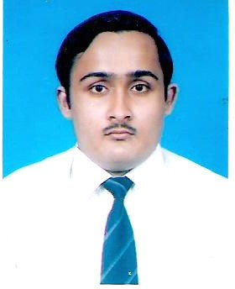

**SAYANTAN RAKSHIT**

(B.Sc, LLB. MBA**)**

Boraichanditala

P.O & P.S. – Chandannagar Dist - Hooghly,

Pin: - 712136. (W.B)

Contact No. :- (+91-33) 26835280 (R)

(+91) 9804712646 (M)

9433735174 (M)

E-mail: [sayantanrakshit@gmail.com](mailto:sayantanrakshit@gmail.com) [sayantanrakshit@yahoo.co.in](mailto:sayantanrakshit@yahoo.co.in)

**Objective:**

Intend to build a challenging career with leading public / private enterprise or industry, which will help me to explore myself fully and realize my potential. Willing to work as a key player in the creative environment as a role of an **Arbitrator** or **Empanelled Advocate cum Representative Lawyer before Hon’ble Court** or any other **similar type.**

**Personal Information:**

Date of Birth : 19th November 1986.

Father’s name : Mr. Swapan Kumar Rakshit

Mother’s name : Mrs. Alpana Rakshit

Sex : Male.

Nationality : Indian.

Language known : Bengali, Hindi, English.

**Professional qualification**

|  |  |  |  |
| --- | --- | --- | --- |
| **DEGREE OR DIPLOMA** | **BOARD OR**  **UNIVERSITY** | **YEAR** | **DIVISION OR GRADE** |
| Hospital Administration (P.G. Diploma) | *Medvarsity - Apollo Hospital, Hyderabad, India* | 2014-2015 | Qualified/Passed (66.67%) |
| Medico Legal System (P.G. Diploma) | *Symbiosis Centre of Health Care, Pune, India* | 2014-2015 | Qualified/Passed (62%) |
| Alternate Dispute Resolution (P.G. Diploma) | *Nalsar University of Law* Hyderabad  collaboration with ICADR *India* | 2013-2014 | First |
| Medical Law and Ethics  (P.G.Diploma) | *National Law School of India University,*  *Bangalore, India* | 2012-2014 | Second |
| MBA  (Health Care Service) | SIKKIM MANIPAL UNIVERSITY,  India | 2012-2014 | Second |
| LL.B. | Burdwan University (West Bengal; India) | 2009-2011 | Second |

# Academic qualification

|  |  |  |  |
| --- | --- | --- | --- |
| **DEGREE OR DIPLOMA** | **BOARD OR**  **UNIVERSITY** | **YEAR** | **DIVISION OR GRADE** |
| B.Sc. (BIO SCIENCE) | Calcutta University (West Bengal; India) | 2005-2008 | Second |
| Higher Secondary (12th Class or its equivalent) | West Bengal Council of Higher Secondary Education | 2005 | Second |
| Madhyamik  (10th Class Or its equivalent) | West Bengal Board of Secondary Education | 2003 | First |

**Project Report Approved:**

1. *Medical Negligence : An Analysis of Recent Judicial Trends* **[** under the Guidance of National Law School of INDIA UNIVERSITY (NLSIU)**,** Bangalore , India**]**
2. *Medical Negligence and Scope for Negotiation & Conciliation* **[** under the Guidance of NALSAR University of LAW, (Hyderabad, India) along with THE INTERNATIONAL CENTRE FOR ALTERNATIVE DISPUTE RESOLUTION **]**
3. *Medical Negligence: Relation with Alternative Dispute Resolution* **[**under the Guidance of SIKKIM MANIPAL UNIVERSITY (DDE), India].

# Skills

* Interaction cum counseling with new client/customer.
* Basic computer knowledge including Microsoft Office suite products (Word, Excel, Power Point and Outlook).
* Hospital Administrative Training at Apollo Hospital (Hyderabad, India).

# Working Experience:

|  |  |
| --- | --- |
| 2013(May) - Present  [7+Yrs PQE]  2012-2016  [4Yrs PQE]  2013(June)  [5+Yrs PQE] | Working as a Junior advocate in the chamber of Mr. Santi Ranjan Das (*Advocate of Hon’ble Supreme Court of India & High Court, Calcutta*) & Mr. Sushanta Kumar Rakshit (*Advocate of Hon’ble Calcutta High Court*).  Advocate at Chinsurah Judges’ Court or Hooghly District Court.  Advocate at Hooghly District Consumer Forum/Court (Medico-Legal Section). |
| **Achievements:** | |

* + ADR certificate from **Hon’ble** **Chief Justice** of Hyderabad High Court, India.
  + Speech on Witches problem in 3rd World war Country in Debate Competition.
  + Participator of Legal Aid & Legal Awareness Camp.
  + Participator as a Delegate at Connexions workshop on Quality and Accreditation Entrepreneurship and Professional Excellence.

Date : 05/05/202121/02/2019

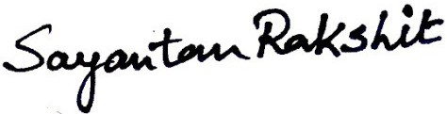

Place : Chandannagar Signature