**Curriculum Vitae**

**SOMDEEP BANERJEE**

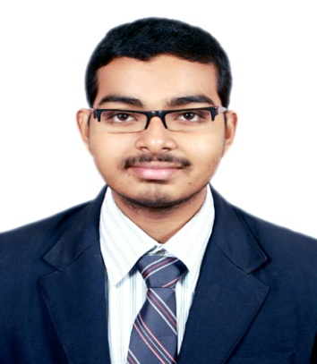

**Father’s name: Joydeep Banerjee**

**Mother’s name: Soma Banerjee**

**Date Of Birth : 02/10/1997**

**Marital Status: Single**

**Address : A-7 Satyen Park, Thakurpukur , Kolkata- 700-104**

**Mobile number: 9830667180**

**E- mail:** [**banerjeesomdeep7@gmail.com**](mailto:banerjeesomdeep7@gmail.com)

**OBJECTIVE**

**To use my knowledge and skills at optimum level to flourish in future with the company.**

**EDUCATION**

|  |  |  |  |
| --- | --- | --- | --- |
| **Qualification** | **Percentage(%)** | **Institution(University/ Board)** | **Year** |
| **MBA in Finance** | **56** | **IGNOU** | **2024** |
| **B.com (Honours) in Accounting & Finance** | **55** | **Vivekananda College**  **( Calcutta University)** | **2018** |
| **Class 12** | **77.2** | **Birla Bharati (CBSE)** | **2015** |
| **Class 10** | **64** | **Birla Bharati (CBSE)** | **2013** |

**COMPUTER SKILLS**

1. **Financial Accounting software – TALLY.**
2. **Word processing software- MS WORD**
3. **Spreadsheet software- MS EXCEL**

**WORK EXPERIENCE**

1. **Talent Pro India HR Pvt. Ltd. Designation-Compliance Trainee. Period- April 2019 to March 2020.**

**Job role and responsibilities-**

1. **Looking after PF (Solving Employees issues such as Activation, withdrawal, coordinating with HO to solve various issues)**
2. **ESI (End to End processes from generating new ESI Number, processing ESI Cards, Submission of ESI Challan).**
3. **IDFC First Bank**

**Designation- Senior Officer**

**Period- May 2020 to Dec. 2020**

**Job role and responsibilities-**

**Worked as a Teller, handling Cash and Non Cash transactions and other Retail operations.**

1. **Talent Pro India HR Pvt. Ltd**

**Designation- Compliance Executive**

**Period- Since February 2021.**

**Job role and responsibilities-**

1. **Looking after PF (Solving Employees issues such as Activation, withdrawal, coordinating with HO to solve various issues)**
2. **ESI (End to End processes from generating new ESI Number, processing ESI Cards, generating ESI Challan).**
3. **Preparation of MIS report using MS-Excel.**
4. **Visiting labor office for documents submission.**

**LANGUAGES KNOWN**

**English, Bengali, Hindi.**

**OTHER INTERESTS**

1. **Reading Story Books, Newspapers, Collecting information, Net Surfing, Eager to learn to something and Skill Development.**
2. **Writing and sharing my own experiences. For example: Travelling experience. As I love to travel offbeat places and enjoy it’s beauty.**
3. **Nature Photography.**

**Declaration- I hereby declare that details mentioned above are True and Correct to the best of my Knowledge and I undertake to Inform you of any changes Immediately.**

**Date:**

**Place:**

**Signature**