**CURRICULUM VITAE**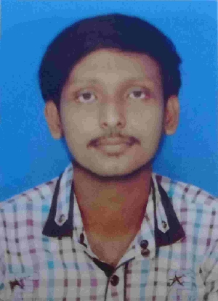

**NAME : Dipanjan Chakraborty**

**ADDRESS : Aghore Sarani, Barendrapara, Rajpur, Kol-149**

**CONTACT NO : 8910887744/8902936188**

**E-MAIL : achak16703@gmail.com**

**PERSONAL DATA**

**NATIONALITY : Indian**

**RELIGION : Hinduism**

**SEX : Male**

**MARTIAL STATUS : Single**

**DATE OF BIRTH : 16/07/2003**

**EDUCATION**

|  |  |  |  |
| --- | --- | --- | --- |
| **QUALIFICATION** | **NAME OF THE BOARD** | **PASSING YEAR** | **PERCENTAGE** |
| 12TH(Commerce) | WBCHSE | 2021 | 78.6 |
| 10TH(General) | WBBSE | 2019 | 81.2 |
| B. Com General | CALCUTTA UNIVERSITY | Pursuing | - |
| Cost Accountant | ICMAI | Pursuing (Intermediate) | 68.5(Foundation) |

**SKILLS**

1. **MS Office.**
2. **Tally ERP 9(Basic).**

* **WORKING AS : ARTICLED TRAINEE.**

_______________________________________________

**HOBBIES**

1. **Watching Movies & Web Series.**
2. **Playing video games**

**LANGUANGES**

1. **Bengali (Read/Write/Speak)**
2. **English (Read/Write/Speak)**

1. **Hindi (Speak)**