Curriculum Vitaé

Name | Chandrama Mukherjee |  | 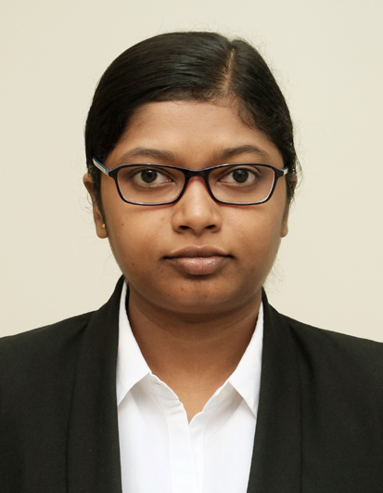
Present Address | Contact Details
BC - 83, Samarpally, Krishnapur,  Kolkata -700102  West Bengal  India | Mobile: | +91-8335804682, +91-9073615001
 | E-Mail: | chandrama11292@gmail.com

Career Objective:
To work with an organization that offers challenges, responsibilities and decision-making opportunities, where I can blend my functional and technical knowledge gained from experience for continuous growth and better career prospects.

Educational Qualifications:
Degree/Certificate | Year | Institute | Board/University | Percentage/CGPA
PGPM  (Finance Major, Analytics Minor) | 2020 | ICFAI Business School, Kolkata | - | 9.64  (CGPA)
B. Tech  (Computer Science and Engineering) | 2015 | Techno India College of Technology | Maulana Abul Kalam Azad University of Technology (Formerly known as West Bengal University of Technology) | 8.70  (CGPA)
Higher Secondary  (Science) | 2011 | Begum Rokeya Smriti Balika Vidyalaya | West Bengal Council of Higher Secondary Education | 86.00%
Madhyamik  (Secondary) | 2009 | Holy Child Institute for Girls | West Bengal Board of Secondary Education | 81.75%

Work Experience:
Name of the organization | Designation | Duration
Tata Consultancy Services Limited | Assistant System Engineer | November 23, 2015 – October 4, 2017 (22 months)
- Developed Reports using BI and OTBI tools in Oracle Fusion.
- Created Reports using OBIEE.
- Generated Reports using HCM Extract in Oracle Fusion.
- Uploaded fresh Data into Oracle Fusion HCM Server using HDL.

Summer Internship(during PGPM):
Name of the Organization | Project Title | Domain | Duration
Skybits Technologies Private Limited | Digital Marketing and Chatbot Development for Skybits Technologies | Data Analytics | February 19, 2019 – May 24, 2019 (3 months)
- Developed a Chatbot for Skybits official Facebook page using Dialogflow.
- Wrote some blogs in Quora referencing Skybits Technologies as a part of Content Marketing.
- Worked on Sentiment Analysis of Parliament Election 2019 using R.

Certificates:
- Certificate of Completion of Python for Finance: Investment Fundamentals & Data Analytics – Online course from Udemy
- Certificate of Completion of Python for Financial Analysis and Algorithmic Trading – Online course from Udemy
- Certificate of Completion of The Complete Digital Marketing Course – Online course from Udemy
Computer Proficiency:
Operating Software: Windows
Application Software: Oracle Fusion, Microsoft Office, Oracle Database, MySQL
Languages: R, Python, SQL
Cloud Computing: Oracle Cloud
Tools Used: SPSS, PSPP, OBIEE, OTBI
Awards & Achievements:
- National Merit Scholarship, 2011-2015
- Certificate of Successful Participation in the 7th National Cyber Olympiad, 2007
- Paintings were published in Artistica Journal, IBS Kolkata, August, September 2018.
- Certificate of Honours in Swimming, Bidhannagar Swimming Association, 2002.
- Certificate of Honour (Winner), Model Making, Inter School Competition, Annual School Fest, Salt Lake School, 2006.
- Completed Vocal Classical, Diploma of Sangeet Visharad Final, Pracheen Kala Kendra, Chandigarh, 2013.
- Certificate of Merit, Dance (Bharatnatyam), Rekha Chitram, Kolkata, 2006.
Interests:
- Writing short stories
- Reading stories
- Gardening
Languages Known:Bengali, English, Hindi
Date of Birth:December 1, 1992

