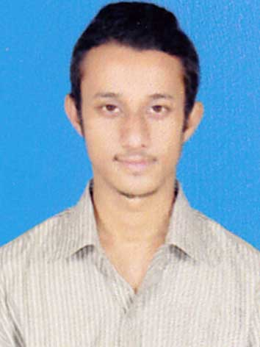

CURRICULUM VITAE

**PANKAJ DUTTA BARUAH**

**Contact No. +918876939391 / 9101098212 email :- ppankajdb@gmail.com**

**OBJECTIVE:** To utilize my knowledge and skills in the Organization that I join as a Part of the team, where I can learn and contribute for mutual growth, with definite hard work and honesty. To become a professional in the top hierarchical position who can take up any kind of challenges in the new millennium age through strategic decision and policy making single headedly for a company, a spark of brilliance that is enough to fire the greatest of Corporate Dreams.

EXPERIENCE

1. Worked as a Emergency Response Officer at GVK EMRI(108 Services) From 01 Aug 2012 to 1st jan 2015.
2. Worked as a marketing representative at FREE POWER SOLAR PVT.LTD. company(dealing with TATA SOLAR POWER) From 15 May 2015 to 31 may 2016.
3. Worked as a market research associate at REINENERGY INFRATECH PVT LTD company (manufacturing of solar home lighting system) From 21 July to 25 March 2017.
4. Worked as a Customer Relationship Officer at HAYAT HOSPITAL From 23October 2017 to 23 october 2018.
5. Working as a Milk Procurement Field Supervisor at “ PURABI DAIRY ” From 24 October 2018 to till Date.

JOB RESPONSIBILITIES

* Successfully implemented Vendor Sales under the guidance of the company’s Director.
* Have done market research on the various solar products to know their market demand and price.
* Emergency Response Officer.
* To give daily report to the Head Office.
* Maintenance of documentation and records.
* To attain to the various needs of the customers.

PROFESSIONAL QUALIFICATION

* Post Graduate Diploma in computer application.

ACADEMIC QUALIFICATION

* H.S.LC. Passed under SEBA in the year 2006
* H.S. Passed under A.H.S.E.C. in the year 2008
* B.A. From G.U. in the year 2012
* PGDHRM From G.U. Pursuing

LANGUAGES KNOWN

* ASSAMESE
* HINDI
* ENGLISH

PERSONAL DETAILS

NAME : MR PANKAJ DUTTA BARUAH

FATHER NAME : AJIT DUTTA BARUAH

DATE OF BIRTH : 21-11-1990

MARITAL STATUS : UNMARRIED

RELIGION : HINDUISM

NATIONALITY : INDIAN

SEX : MALE

PARMANENT ADDRESS : VILL- MANAHKUCHI

P.O.- MANAHKUCHI

DIST.- KAMRUP(ASSAM)

PIN- 781104

UNDERTAKING

Define myself as goal oriented person. I would always like to see my today better than yesterday both personally and professionally.

I hereby declare and undertake that the above information is true to the best of my knowledge

And belief

**SIGNATURE**

**DATE: 03/09/2020**

**PLACE: HAJO (PANKAJ DUTTA BARUAH)**