RESUME  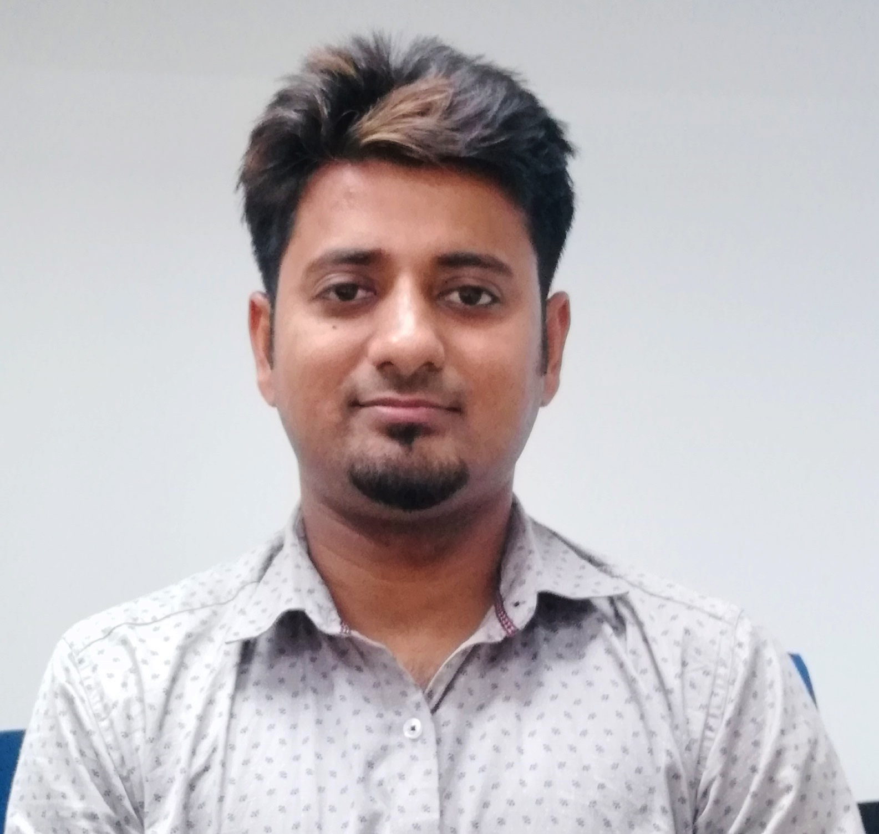  DIPAN SARKAR  Contact Information:  Permanent Address:  25/1,Kaibartta Para Road,  Bhatpara-743123,  Dist.-North 24 Pgs,  Kolkata, West Bengal.  E-Mail:  dip_star@yahoo.co.in  Contact No.s  Mob : 7003492634  Residential No. : (033) 25816718  Personal Data:  Date of Birth : 17/11/1984  Father’s Name: Pradip Sarkar  Sex : Male  Nationality : Indian  Marital Status : Married  Languages  Known : English  : Bengali  : Hindi  Interests and  Hobbies : Playing Football,  Listening to Music. | OBJECTIVE & PERSONAL PROFILE  Seeking an organization where I can utilize my skills, knowledge and abilities to provide key analytical support while being resourceful, innovative and flexible. Ambitious and looking forward to play a vital role and able to be a good team player. Performing consistently, delivering quickly and accurately and capable of priority selection to ensure deadlines are met without compromising with the quality.  ACADEMIC QUALIFICATION  COMPUTER SKILLS  MS Word, MS Excel Advance Skills (Pivot tables, Vlookup, Hlookup)  OFFICE SKILLS & COMPITENCIES  - Fund Raising & Fund based Budgeting  - Preparation of various Financial reports & Financial Planning  - Working in a team & Corporate Interaction  - Making payment & Reconciliation  - Loan processing (Institutional Finance)  - Handling Auditors  EXPERIENCE & JOB PROFILE  Place:-  Date:- (DIPAN SARKAR)
  NAME OF THE INSTITUTION | NAME OF THE EXAMINATION | BOARD / UNIVERSITY | % OF MARKS | YEAR OF PASSING
  IBRAD | MBA(Finance) | AICTE & WBUT | 74.1 | 2010
  R.B.C. College | B.com(H) | C.U | 60 | 2006
  Bhatpara High School | H. S. | W.B.C.H.S.E | 63.33 | 2003
  Bhatpara High School | Madhyamik | W.B.B.S.E | 73.13 | 2001
  ASA International India Microfinance Limited. : [NBFC-MFI Regd. By RBI] | Designation: Manager Finance & MIS, Duration: Feb’16 to present
  - Preparing various MIS reports for external & internal requirement
  - Financial analysis of monthly Profit & Loss, Balance Sheet and analyzing various credit ratios for submission to internal and external parties.
  - Preparing various compliance related reports & submission of the same within due date.
  - Working with the team, assisting the higher management, conducting meetings & presentations, Handling Audit & Preparing compliance report.
  Uttrayan Financial Services Pvt Ltd. :  [NBFC-MFI Regd. By RBI] | Designation: Asst. Manager (Fin), Head Office  Duration: Oct’2014 to Feb’2016
  - Fund raising from different lenders for the requirement of disbursement among clients. Sending loan proposal to different Bankers/ Financial Institutions, regular communication and follow-up with them which involves desk-level employee to top-management, after receiving the sanction letter of loan arranging various company documents, negotiation with lenders regarding the terms & conditions of sanction, documentation process while making communication with company’s legal team, disbursement of the loan with the help of treasury department. Then the servicing portion of the loan- scheduled payment making, compliance, finally the loan closure.
  Bandhan Financial Services Pvt Ltd. :  [NBFC-MFI Regd. By RBI] | Designation: Jr. Officer (Fin), Head Office  Duration: Oct’11 to Dec’13
  - Fund raising from different lenders for the requirement of disbursement among clients. Sending loan proposal to different Bankers/ Financial Institutions, regular communication and follow-up with them which involves desk-level employee to top-management, after receiving the sanction letter of loan arranging various company documents, negotiation with lenders regarding the terms & conditions of sanction, documentation process while making communication with company’s legal team, disbursement of the loan with the help of treasury department. Then the servicing portion of the loan- scheduled payment making, compliance, finally the loan closure.

