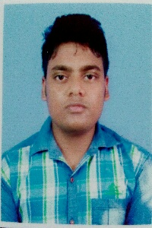
Bio data

Name. :- SAMIR MAITY
C/o. :- swapan maity
Date of birth :- 01/02/1996
Cast. :- general
Nationality :- indian
Riligion. :- hinduism
Matrial status :- unmarried
Hight. :- 162cm
Chest. :- 90cm
Weght. :- 60kg
Mob. :- 9679653177
Email. :- sm1455180@gmail.com
Educational qualification:-
Exam name | Board/University | Passing year | Marks | Division
Madhyamik | WBBSE | 2011 | 412 | 2ND
Higher secondery(arts) | WBCHSE | 2013 | 335 | 1ST
BA(geography) | VU | 2016 | 775 | 2ND
MA(geography) | BU | 2018 | 1303 | 1ST
B ed | Bu | 2019 | 617 | 1st

Skill:- HONEST,HARD WORKING,

COMPUTER KNOWLEDGE:- SIX MONTH and 1 YEAR COMPUTER CERTIFICATE.
EXPERIENCE:- 1. MICROFINANCE
2. PART TIME TEACHER IN HIGH SCHOOL (GEOGRAPHY) 2 YEARS
3. Back office 2 month

