**CHITRABIR DEBNATH**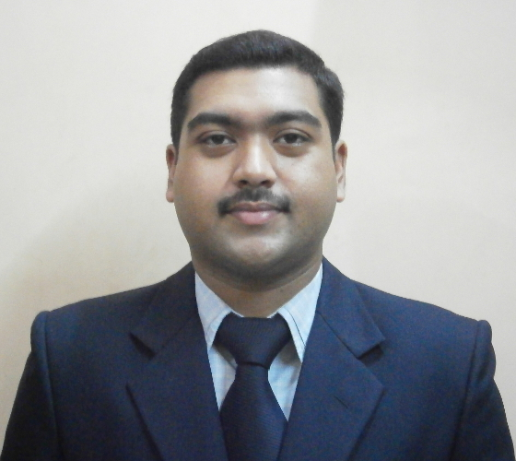

Date of Birth: 14 June 1982

+91 9831011498

chitrabir.debnath@gmail.com

76/3, Dharmatala Lane, Shibpur, Howrah, West Bengal 711102, India

**SKILL**

Management, Strategic HR, Organization structure, Policy restructure, Transformation planning, Budget planning, Talent acquisition, Performance management, HR compliance, HR audit, Employee training, Talent retention, Employee engagement, Cultural development, Succession planning.

Administration, Insurance underwriting, Claim investigation, Collection analysis.

Gold jewellery valuation, audit and training.

Concept designing.

**EXPERIENCE**

Human Resource - Strategic, from January 2016 to January 2021

Premier Food Industries LLC; Riyadh, Kingdom of Saudi Arabia

*Profile: HR management, Strategic HR, Organization structure, Policy restructure, Transformation planning, Budget planning, Talent acquisition, Performance management, HR compliance, HR audit, Employee training, Talent retention, Employee engagement, Cultural development, Succession planning, Strategic advisor to president.*

Freelance Mystery Auditor, from May 2015 to January 2016

Wemark Marketing Co.; West Bengal suburban region, India

*Profile: Mystery audit for different products and services.*

Freelance Invigilator, from March 2015 to January 2016

British Council India; Kolkata, India

*Profile: Invigilator and organization of english examination conducted by British Council, India.*

Freelance Auditor, Valuer and Trainer, from December 2014 to January 2016

Global Gold Foundation; Uttar Pradesh region, India

*Profile: Gold jewellery audit and valuation of bank, Gold jewellery valuation trainer.*

Assistant Manager, from September 2008 to March 2014

Max Life Insurance Co.; West Bengal suburban region, India

*Profile: Administration, Insurance underwriting, Claim investigation, Collection analysis, Employee training & development, Agency recruitment (IRDA standard), Operations audit.*

Operation and Customer Service Executive, from March 2004 to September 2008

L&L Services and csDatamation Services Pvt. Ltd.; North- Eastern region of India

(Outsourced staff of Max Life Insurance Co.)

*Profile: Administration, Insurance underwriting, Customer compliance and grievance analysis, Claim investigation, Collection analysis.*

Designer, from June 2003 to March 2004

Datainfo Advertisement Agency; Howrah, India

*Profile: Concept designing for advertisements, company logo, business card.*

Teacher, from June 2000 to June 2003

WEBEL Computer Training Center; Howrah, India

*Profile: Computer teacher for both theoretical and practical.*

**QUALIFICATION**

Educational:

- Master’s in Business Administration with dual specialization (Finance and Human Resource) from University of Sikkim and Manipal, India; 2013.

- Bachelor of Arts and Humanities from University of Calcutta, India; 2007.

- Higher Secondary (10+2th) with Science from W.B.C.H.S.E., India; 2000.

- Secondary (10th) from W.B.B.S.E., India; 1998.

Professional:

- FSSC/ISO 22000 Internal Auditor certificate from Intertek, Saudi Arabia; 2020.

- FSSC/ISO 22000 Internal Auditor and Implementation certificate from SGS, Saudi Arabia; 2019.

- GMP certificate from Truly Nolen, Saudi Arabia; 2019.

- International Trainer certificate (IADT) from BEMCON, Saudi Arabia; 2018.

- Food Safety (Level 3) Highfield UK, certificate from BEMCON, Saudi Arabia; 2018.

- Occupational Health and Safety Highfield UK, certificate from BEMCON, Saudi Arabia; 2017.

- H.A.C.C.P. (Level 3) Highfield UK, certificate from BEMCON, Saudi Arabia; 2016.

- Civil Defense certificate from Gov of West Bengal, India; 2015.

- Child Protection Awareness certificate from British Council, India; 2015.

- Certified Gold Valuer from Gov of India; 2014.

- Diploma in Human Resource Management from Alison online; 2013.

- Growth Strategies for Business certificate from Alison online; 2013.

- Critical Skills for Entrepreneurs certificate from Alison online; 2013.

- Diploma in Hardware and Networking from Gov of West Bengal, India; 2006.

- Diploma in Software Application from WEBEL (Gov of West Bengal), India; 2003.

**AWARD**

- Superman of Customer Service; M.P.E.F. Newsletter, 12th issue of Max Life Ins. Co.

- Star Club member “Gold Coin”; Max Life Insurance Co.; 2013.

- Certificate of Recognition, Max Life Ins. Co.; 2013.

- “Masters of the Game” Award, Max Life Ins. Co.; 2013.

- Customer Retention Award, Max Life Ins. Co.; 2012, 2013.

- Certificate of Achievement, Max Life Ins. Co.; 2011, 2012, 2013.

- Customer Appreciation Award, Max Life Ins. Co.; 2010, 2011, 2012, 2013.

- Hall of Fame, Max Life Ins. Co.; 2009, 2010, 2011, 2012, 2013.

- “You are a Winner” Award, Max Life Ins. Co.; 2009, 2010, 2011, 2012, 2013.

- Certificate of Excellence, Max Life Ins. Co.; 2009, 2010, 2011, 2012, 2013.

- “The Best Performing Operations Team” Award, Max Life Ins. Co.; 2008.

**PROJECT**

- Cash denomination and reconciliation, October 2008 to March 2009; Max Life Ins. Co.

- Reduction of cheque bounce, December 2008 to February 2009; Max Life Ins. Co.

- Streamline of policy-issuance time, December 2008 to January 2009; Max Life Ins. Co.

- Internal audit and control process, June 2010; Max Life Ins Co. for MBA in Finance from University of Sikkim and Manipal.

- Organization culture and climate analysis, December 2012; Max Life Ins Co. for MBA in HR from University of Sikkim and Manipal.

**PUBLICATION**

- “Gold Jewellery Valuer’s Handbook” (English and Bengali version); pothi.com, lulu.com.

- “Dairy Troyi” (Bengali poetry); pothi.com, lulu.com, amazon.com, createspace.com.

- Authoring thesis on organizational restructuring with cost effective management system.

**OTHER**

Language: Bengali (Native), Hindi, English

Activity: Painting and drawing, writing, photography, swimming, mime, travelling.

Creative links: cd7.deviantart.com, cd7s.wordpress.com, flexistickfigures.tumblr.com.