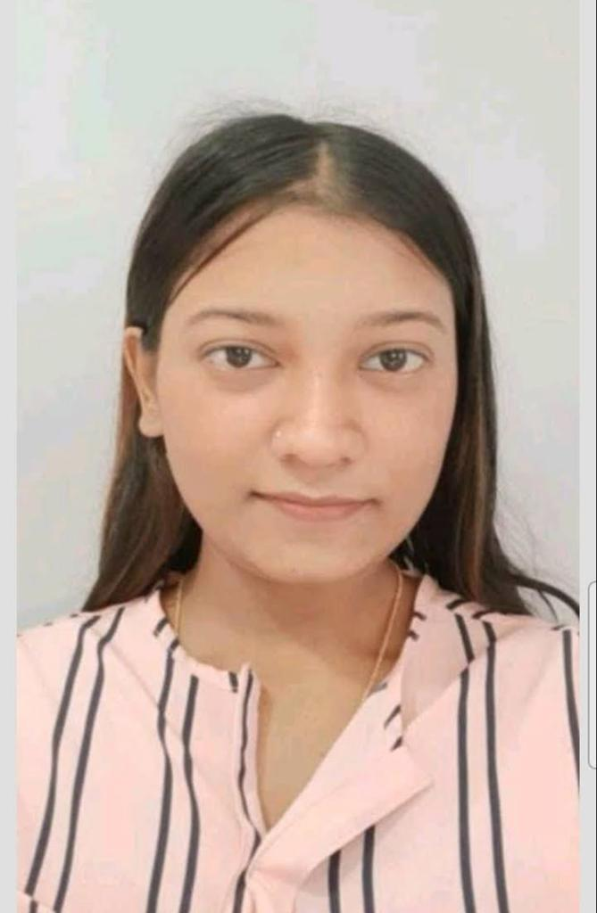 |  |  |  | JUHI  JAISWAL
HDB FINANCE SERVICES LIMITED
RELATIONSHIP MANAGER
PRIME SALES DEPT

PROFESSIONAL SUMMARY :- A dedicated and a career focused sales professional who uses effective questioning to establish customer’s needs, and then quickly finds the best products and services for them. Determined and positive person who loves accomplish goals. Experience in dealing with clients both over the phone as well as face to face. Right now looking for an opportunity to become a part of a well established company that has fast moving and buzzing sales environments.
OBJECTIVE: • To challenge professionals across industry and to achieve the target set by company. • Willing to work as a team coordinator. • Interested in working with banking and finance and comfortable to work with other industries also.
STRENGTHS: • A good team player with positive attitude. • Always ready to acquire knowledge. • Team-oriented personality. • Ability to work under pressure. • Determination combined with the dedication has rewarded me in the past and with the same confidence.
WORK EXPERIENCE: • carrying an experience of 1yrs 8months • Currently associated with HDB FINANCE SERVICES LIMITED as RELATIONSHIP MANAGER in virtual prime sales dept AND COGINZANT as PROCESS ASSOCIATE in MORTGAGE DEPT .
• To maintain MIS reports on regular basis for FTD,MTD and YTD as well for businesses login. • Handholding new joiners in channel. • To deal with all kind of loan , investmentplans and handle customer query . • To utilize digital platforms and IVR process on regular basis. • customers visit in office whenever it required. • To maintain and achieve persistency on regular basis. • Always maintain ATS of the channel and oneself.
ACHIEVEMENTS: • Got Promoted to CAM from SDM during 1st First Star cycle. • Qualified for the LI Contest for Barcelona and Bangkok

ACEDEMIC QUALIFICATIONS:
Exam passed Board Year of Passing Percentage
Class 10th WBBSC 2015 56%
Class 12th WBCHSE 2017 80%
B.Com Accountancy (H) CU 2020 57%

DECLEARATION :
I hereby declare that the above particulars are to the best of my Knowledge and belief.
Date:
Place: JUHI JAISWAL
 | Personal Profile :
77/ AHU BOSE LANE
HOWRAH-711101
 |  | 8240650367
 |  | juhijaiswal1238@gamil.com
Date of Birth: 04/04/19997

Father’s Name: RAJ KUMAR JAISWAL

Gender: Female

Nationality: Indian Religion: Hindu
Marital Status: Single
Languages Known: English Hindi
Hobbies: Teaching, Cooking, Travelling, Making Friends & Enjoy working closely with others.

Current Salary:- 3.lac+CPB

