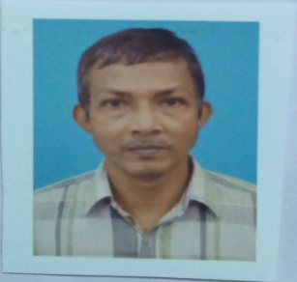CURRICULUM VITAE

***NISITH KUMAR DAS***

PH: (+91) 8902644511

E-Mail :nisithkrdas@gmail.com

#### *CAREER Objective*

To see myself as a successful corporate personnel in a renowned brand, within the forthcoming five years henceforth.

#### *Proficienc*y

* **In order strive and achieve my goal, I feel that I have the following qualifications :**

To work diligently and sincerely under pressured atmosphere for a long period of time.

Have command over my language and thus can communicate well with all sections of the society.

#### *PROFESSIONAL EXPERIENCE*

* Last working in **Syama Prasad Mookerjee Port** as **I/O Staff Cum Librarian(Computer) from 10th November 1997 to 31st March, 2023.**
* Previous working as **Lower Division Clerk from 2nd February 1993 to 9th November 1997** in **Raja Rammohun Roy Library Foundation, Kolkata (Ministry of Human Resource, Govt. of India).**

***HIP***

#### *ACADEMIC Credentials*

|  |  |  |  |  |
| --- | --- | --- | --- | --- |
| **YEAR OF PASSING** | **QUALIFICATION** | **BOARD/UNIVERSITY** | **INSTITUTION** | **PERCENTAGE OF MARKS** |
| 1988 | B.Com(Hon) | CALCUTTA UNIVERSITY | Bangabasi Collage of Commerce | 42.8% |
| 1983 | Higher Secondary | W.B.C.H.S.E | Dum Dum Kumar Asutosh Institution | 49.0% |
| 1981 | Madhyamik | W.B.B.S.E | Seth Bagan Adarsha Vidyamandir | 38.5% |

#### *EXTRA CARRICULAR ACTIVITIES*

|  |  |  |  |  |
| --- | --- | --- | --- | --- |
| **YEAR OF COURSE** | **ACTIVITIES** | **CERTIFICATE HOLDING FOR** | **MARKS OBTAINED** | **PERCENTAGE OF MARKS** |
| 1988-1989 | Passed Diploma in Computer Application | South Eastern Railway Women’s Organisation | 370 | 52.86% |

#### *HOBBIES*

* Follow TV News
* Interact with new people and make new friends.

#### *STRENGTH*

* I am task driven and Integrity, Commitment, Passion are my major strengths.

#### *Weakness*

* I do not like persons who do not keep their commitments.

#### *linguistic abilities*

|  |  |  |  |
| --- | --- | --- | --- |
| **LANGUAGE** | **READ** | **WRITE** | **SPEAK** |
| ENGLISH | YES | YES | YES |
| HINDI | YES | YES | YES |
| BENGALI | YES | YES | YES |

***PERSONAL INFORMATION***

Father’s Name : Mr. Khagendra Nath Das

Father’s Occupation : Retired(S.E.Rly)

Marital Status : Married

Date of Birth : 18-03-1963

Religion : Hinduism

Nationality : Indian

Height : 5'-5"

Sex : Male

Residential Address : 5/6, Seth Bagan Road, Dum Dum, Kolkata-700030

#### *DECLARATION*

I believe to the best of my knowledge that the above mentioned data and information submitted are true and correct.

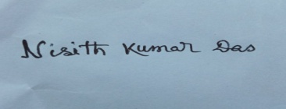

***PLACE: KOLKATA***

***( NISITH KUMAR DAS )***