Curriculum Vitae (CV) of Supriyo Pal

Name: Supriyo Pal  Date of Birth: 27/12/1981  Nationality: Indian  Email Id: supriyopal_1981@yahoo.co.in  Mobile No: 9903396177, 7980678213 | 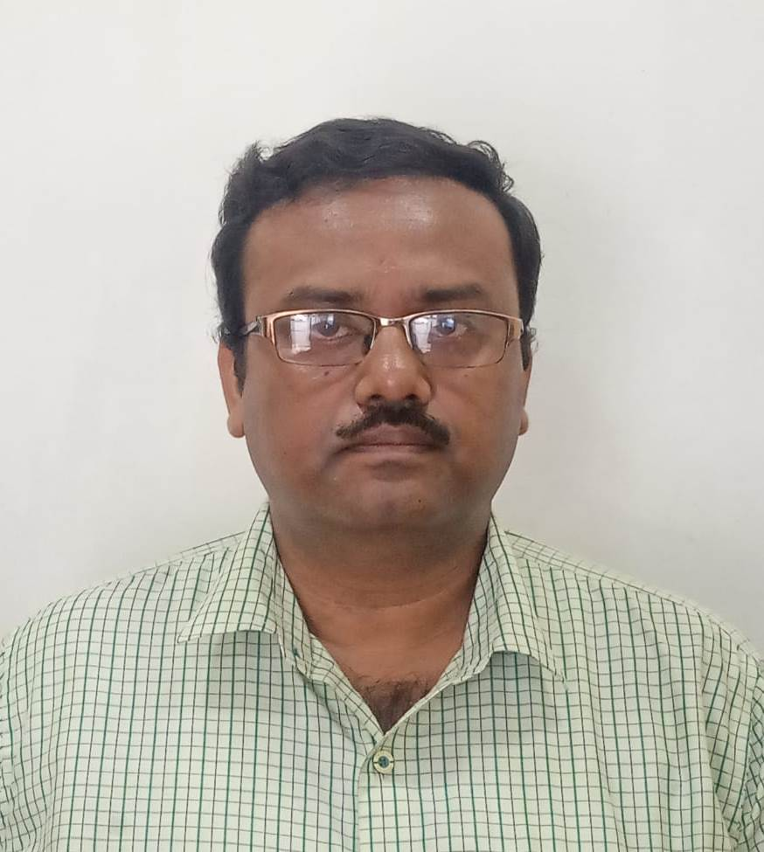

Professional Qualification:
- MBA (Specialization in Finance & Banking management, marketing) from IPSAR Cuttack under BPUT, in 2007
- IRDA Qualified
Educational Qualification:
- B. Com (Hons) From Calcutta University
- 10+2 From W.B.B.H.S.E
- 10th From WBBSE
Contact Address:
P-276/A, Mudiali Road, PO-Garden Reach
Kolkata-700024
Key Professional Skills:
- Working as a backup BM
- Operation Management and customer service
- Expert in Selling of life Insurance, general Insurance, Mutual funds
- Achievement of individual sales target and branch sales target,
- Business development and sales planning
- CASA growth
Work Experience:
Total experience: 12 years of experience in various Banks
Last Employer: Axis Bank for last 4 months. ( Manager Grade)
Previous Employers:
1. HDFC BANK for total 9 years
Location- Budge Budge, Kolkata
Designation- Manager
Job Role- Operation Manager ( Back up BM)
Job Profile:
- Back up BM
- Expert in selling of life Insurance, general Insurance
- Active participation in sales, business development planning.
- New CASA
- Account opening process as per KYC and AML policy
- Supervision of productivity of PB Sales, Teller and welcome desk.
- Customer service
- Achievements of individual sales target and branch target

2. The Bank of Rajasthan Ltd (now merged with ICICI Bank)
Location: Guwahati, Assam
Designation: Officer
Period: 2 Years 6 Months
Job Profile:
- Branch banking operation.
- Clearing cheque entries inward and outward.
- Cash receipt & payment in computer.
- Pass book printing, issue of cheque books in computer.
- Account opening in computer.
- Handling customer quarries over phone and counter.
- Verification of entries made by clerical staff.
- In charge of KYC of the branch
- Signature scanning and uploading
- Encoding of cheques

3. LIC Mutual fund AMC
Designation- Service Officer

Duration- 9 Months
Location: Kolkata

Personal Information:
Father’s Name : Mr. D.K Pal.
Mother’s Name : Mrs. Usha Pal
Sex : Male
Marital Status : Married
Hobbies : Traveling & Photography

References:
- Sudipta Pal , Sr DGM, RITES Ltd (A Govt of India Enterprise)
Mob-9748286962
- Sanjib Saha ( Manager Bandhan Bank)
Mob- 9735012120

Languages Known:
Bengali, English. Hindi, Assameese, Oriya

Declaration
I hereby declare that all the above information is true in best of my knowledge.

SUPRIYO PAL

