**CURRICULUM VITAE**

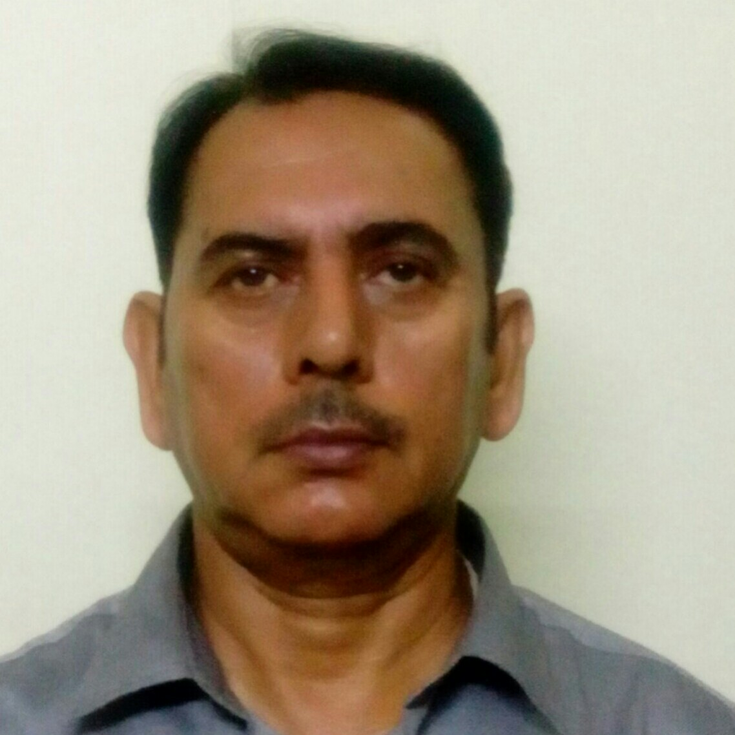

**PRABIR CHATTOPADHYAY**

Abhyudoy Flat. B/21/5, Phase IV, EKTP ,Kolkata -700107

Mobile : 9433256716 E-mail : contact1_prabir@rediffmail.com

**Career Objective::** Seeking to handle ever increasing responsibility & Challenging assignments

harnessing my education qualification, knowledge thereby achieve the organization.

**Education Qualification::** Bachelor of Commerce (Calcutta University)

**Technical Qualification::** Diploma in computer application from the British Institute.

**Language ::** Basic, COBOL, C & Oracle 9i

**Operating System :**: MS Dos, UNIX, VMS, Linux Windows & Solaris-9 (SUN MICRO SYSTEM)

**Application Software :**: Excel, Fox Pro, CorelDraw and Auto text

**Computer hardware ::**  Course Under Calcutta University

**Job Profile:**

|  |  |  |
| --- | --- | --- |
| **Organization** | **Duration** | **Designation** |
| **Peerless General Finance & Investment Co. Ltd** | **Since 2001** | **Systems Executive**   * System Software loading & Maintenance * Software testing and debugging for new version. * Problems Analysis solve and updating and branch database. * Various reconciliation jobs at peerless computer centre & also Branch end. * Data migration through Oracle Loader from COBOL to Oracle. * Application Software Implementation , Developer & **Training**. |
| **CAD CAM Consultants (P) Ltd.** | **From**  **1999**  to  **2001** | **Branch Computerization support personnel under the direct control of PGFI**  **Assignment includes:**   * Loading of different version of branch computation software from time to time * Training of branch personnel in there functional computerized areas. * Trouble shooting supports at the branch and extended counters. * Assistance provided in the generation of various statements on a periodic emergency basic |
| **Deputation at KEI Graphics (P) ltd. (New Delhi)**  **Technical manager**   * Executed a project of Geographical information system for M/s Gujrat Industrial Power limited to create a ling between DBMS and GIS and make software to solve their queries. |
| **Guest Lecturer**   * Technical teachers tanning institute (Govt. of W.B.)   Lecturer (Guest) of post diploma Course in CAD-CAM. |

|  |  |  |
| --- | --- | --- |
| **CAD CAM Consultants (P) Ltd** | **From**  **1996**  to  **1999** | **Centre Manager**   * Video Studio and Multimedia Division. |
| **From**  **1990**  to  **1995** | **Asstt. Manager (Training)**   * Trained up corporate executive **from M/S Paharpur Cooling Towers Limited, Siemens Ltd., Philips India Ltd, India Aluminium Co. Ltd, Hindustan Paper Corporation Ltd, BieccoLawrio Ltd, And Architecture Students OfJadavpur University** along with the other general students. |
| **Informatic Management and Consultant** | **From**  **1988**  to  **1990** | **Programmer.**   * Created Inventory System for **M/s HeizaBollersIndiaPrivate Limited** for coding the items and doing part of programmes as per instruction of system analyst. * Made software for two stock statements for the famous tea blender **M/s. Himatsingka& Company and CB Forms (P) Limited** with the help of FoxPro. |
| **Lakhotia Computer Centre** | **From**  **1987**  to  **1988** | **Junior Programmer / Lecturer**   * For Imparting training to general Student * Making Stock Statement Software **for M/s Plus Point Distributor and Druggist** with the help of FoxBASE Software. |

Date of Birth :: 23rd January, 1962

Language proficiency :: BENGALI, ENGLISH & HINDI

**Date::** __________________________

**PRABIR CHATTOPADHYAY**