
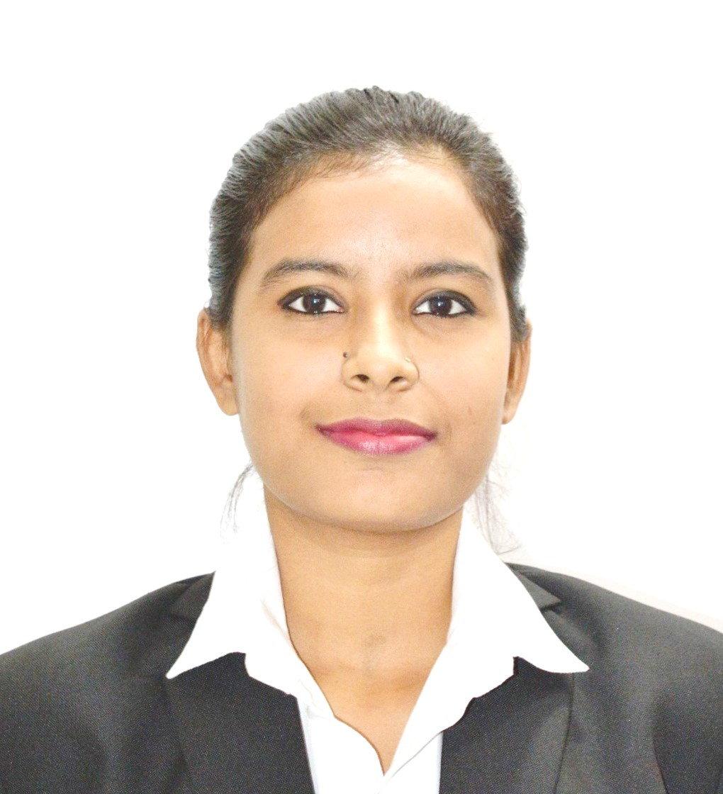
PRAGATI SINGH
D.O.B. 03.11.1996, Gender: Female
E-mail: pragati.singh.19.21@gmail.com Contact No.: +91 6291724798
Permanent Address: B-52H/10, CHAULPATTI ROAD, BELIAGHATA KOLKATA-700010
ACADEMIC QUALIFICATIONS
Year | Examination | Institute | Board/University | Percentage
2020 | PGPFM | Bengal Institute of Business Studies | BIBS + NSE | 70.75%
2018 | B.COM(H) | Chittaranjan College | C.U. | 45.88%
2015 | XII | Arya Kanya Mahavidyalaya | W.B.C.H.S.E. | 80%
2013 | X | Khanna High School | W.B.B.S.E. | 57.71%
PROFESSIONAL CERTIFICATES
Year | Certification | Series | Certified By | Year | Certification | Series | Certified By
2019 | Mutual Fund | NISM VA | SEBI | 2020 | Capital Market Dealers Module | NCFM | NSE
2020 | Commodity Derivatives | NISM XVI | SEBI | 2021 | Investment Analysis & Portfolio Management | NCFM | NSE
2021 | Currency Derivatives | NISM I | SEBI | 2021 | Beginner to Pro in Excel |  | UDEMY
INTERNSHIP PROGRAM
Motilal Oswal Financial Services Limited August 2020 – November 2020
- Intern as an Equity Advisor where my responsibilities were to talk with different clients and make them understand about market and MOSL Products.
INTERNSHIP PROGRAM
Akvo Atmospheric Water Systems Pvt. Ltd. December 2020 – February 2021
- Here my responsibilities were to assist to financial manager with Accounts work as BRS, Reconciliation of purchase book and sales book, journal entries, adjusting the entries and tagging the bills, checking the entries.
KEY PROJECTS
- Ultimate Startup Plan: Conceived and presented a unique startup plan in this business plan competition.
- Academic Project 1: A detailed research on Non-Performing Assets.
- Academic Project 2: A detailed research on Inflation.
- Academic Project 3: A detailed research on Active and Passive Investment.
- Theme day: A competition where we have to represent OUR TEAM.
ACHIEVEMENTS
- Successfully completed Office Assistant Course.
- Qualified for the finals in inter house competition.
EXTRA CURRICULAR ACTIVITIES
- Completed Job training in SMILE Foundation.
- Completed training in Advance Tally with GST.
- Completed CFI EXCEL CRASH COURSE.
- Participated in college seminars as MGIS event.
- Visited to Eureka stock and share Broking service Ltd.

