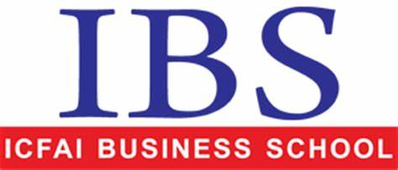

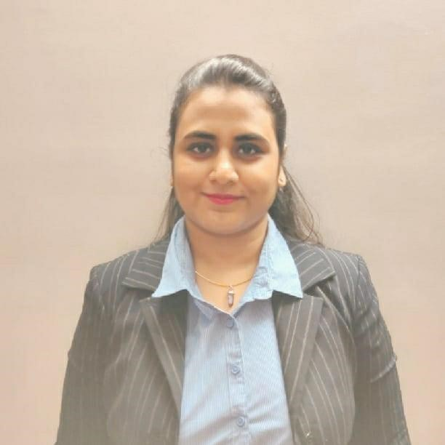

**Name :** Purti Gupta

**Date of Birth :** 08.02.1996

**Mobile :** 8100170681  **Email:** purti.gupta19@ibsindia.org

**Academic Qualification:**

|  |  |  |  |  |
| --- | --- | --- | --- | --- |
| **Degree/Certificate** | **Institute** | **Board/**  **University** | **Year** | **% / CGPA** |
| PGPM | ICFAI Business School | - | 2019-2021 | 6.96 |
| B.Com. (Hons) | The Bhawanipore Education Society College | University of Calcutta | 2015-2018 | 48.33 |
| Class 12 | Birla Bharati | CBSE | 2015 | 63 |
| Class 10 | Birla Bharati | CBSE | 2013 | 64.6 |

**Summer Internship:**

|  |  |  |
| --- | --- | --- |
| **Name of the Organization** | **Project Title** | **Duration** |
| Suskan Consultants Pvt.Ltd | Personal Wealth Management | 14 weeks |

**Salient Points:**

* A Financial Planner was made, to make a plan for my client’s retirement, child education & marriage.
* A One Page Calculator was used to find out the investment and the paybacks on different SIP plans.
* Various Posters and Banners were generated and circulated to increase customer awareness on investment.
* Presentations were made to senior officers of Bajaj Automobile, to increase their awareness of various investment avenues.

**Additional Qualifications/Certifications:**

* ‘Analyzing & Visualizing Data with Excel’, to be issued by IBS Bangalore -on going
* ‘Basics of Customer Service’ issued by TCS
* ‘GST in 90 minutes’ issued by TCS
* ‘Basics of Wealth Management’ issued by TCS
* ‘Rebalance Volatility Certification Course’ issued by NSE
* ‘TCS iON Career Edge-Knockdown the Lockdown’
* ‘Understanding the Settlement in Financial Sector’ issued by TCS
* ‘Understanding Collateral Management’ issued by TCS
* ‘Risk Management in Financial Sector’ issued by TCS

**Awards and Achievements :**

* Member of the winning team in the Entrepreneurship Club Event in July 2019 at IBS-K.
* Participated in the National Level Online Quiz on ‘Business Management’ of RERF.
* Participated in the Cultural event in July 2019 at IBS-K

**Computer Proficiency :** Microsoft Office& Advanced Excel

**Interests :** Travelling, Cooking & Listening to Music

**Languages known :** English, Hindi & Bengali

**Address** : Dhanshree Tower, 70 D.H. Road, Kidderpore, Kolkata-700023