**CURRICULUM VITAE**

NAME: ROUMYA SEN

ADDRESS:

VILL:NEOR

POST: SAKNARA P.S:MADHABDIHI DIST:PURBA BARDHMAN PIN:713421 WEST BENGAL

CONTACT NO: 7679691562

E MAIL: SENROUMYA0[@gmail.com](mailto:REEK9735@gmail.com)

|  |  |  |  |
| --- | --- | --- | --- |
| **ACADEMIC QUALIFICATION** | | | |
| **EXAM** | **BOARD** | **YEAR OF PASSING** | **PERCENTAGE** |
| MADHYAMIK | WBBSE | 2013 | **32%** |
| HIGHER SECONDARY | WBCHSE | 2016 | **51.4%** |

**EXTRA QUALIFICATION**

* 1. BASIC IN COMPUTER APPLICATION.

**PERSONAL DETAILS**

FATHER’S NAME: CHANCHAL SEN

MOTHER’S NAME: ANU SEN

DATE OF BIRTH: 7TH MAY, 1997

SEX: MALE

NATIONALITY: INDIAN

RELIGION: HINDU

CAST: UN-RES

MARITIAL STATUS: UNMARRIED

HOBBY: READING, WRITING, TRAVELLING

LANGUAGE KNOWN: BENGALI, ENGLISH

**Declaration: I hereby declare that the information furnished above is true to the best of my knowledge & I hold the responsibility of its authentication.**

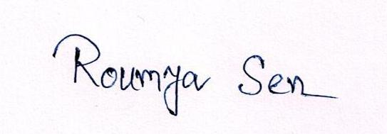

# DATE:

**PLACE: NEOR ----------------------------------------**

**ROUMYA SEN**