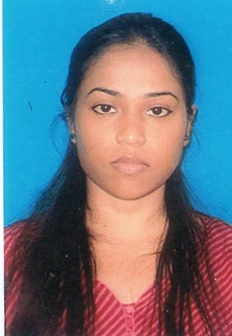
` CURRICULUM VITAE

Suparna Biswas

OBJECTIVE

To explore my creativity, skills & Knowledge successfully in my field. Except an challenging tasks around my capacity initiating the participative culture that builds positive attitude towards job responsiblilities. I have an ability to accomplish an task around my knowledge. Seeking for a growing organization which will allow me to be successful individual and professional.

Academics

Degree | Year |  | Institution |  | Board/  University |  | Specialization |  | Division
B.A |  | 2013-2016 |  | Pandu College |  | Guwahati University |  | POSC,ENGL,  ADBE,EDUC |  | Second
(12th) |  | 2011 |  | Bidya Mandir Higher Secondary School |  | Assam Higher Secondary education Council |  | POSC,ADBE,  EDUC |  | Second
(10th) |  | 2007 |  | Bidya Mandir Higher Secondary School |  | Board of Secondary Education, ASSAM, GUWAHATI |  | GESC,MATH,ENGL,BENG,HINDI-- |  | Third

COMPUTER SKILLS:

Basic Knowledge in Computer

JOB EXPERIENCE:

Two and half years of experience in HDB Finance Services.

LANGUAGES KNOWN:

- English, Hindi ,Bengali, Asssamese
Personal Information

Address : Sheoraphuli, shibtala 3(2-2-1) West Bengal, Hooghly 712223
Phone no : (+91) 8697433524
E-mail : suparnabiswas355@gmail.com
Date of Birth : 12 th march, 1990
D/O : Mr. Sandip Kumar Biswas
Sex : Female
Nationality : Indian
Marital Status : Single

DECLARATION

- I hereby declare that the information submitted above is best to my knowledge.

Date- Suparna Biswas

