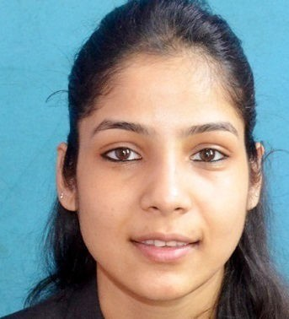

|  |  |  |  |  |  |
| --- | --- | --- | --- | --- | --- |
|  | | **Nidhi Jain**  **DOB**: 05-05-1995  **Address**: 43, Shyam Nagar Road, Natural City,  Block- N, Flat 2b, Kolkata  **City**: Kolkata  **Pin**: 700055  **Email**: [nidhi.pgdm10nc@globsynbschool.com](mailto:nidhi.pgdm10nc@globsynbschool.com)  **Mobile No.**: 9830108094 | | | |
| **Profile Summary:**  I look forward to work with an organization which offers various responsibilities like:   * Monitoring the **day-to-day financial operations**, such as invoicing, accounting and other transactions. * Oversee financial departments. * Track the company's financial status. * **Stay up to date** with technological advances and **accounting software** to be used for financial purposes. * Keep **accurate records** **for all daily transactions** * Managing all the administrative tasks such as maintaining records, preparing datasheets etc. * Coordination with Finance, Administration for necessary support to the team * Compliance works if any, * and in addition to this any tasks entrusted to me. Apart from this, enhance my competencies like ability to achieve stretched targets assigned to me, work ethics etc. Seeking a position to work in a challenging environment which provides an opportunity to enhance my technical skills and knowledge, this could provide me an insight into new aspect so that it will be helpful for my career. | | | | | |
| **EDUCATION** | | | | | |
| **Year of Completion** | **Course** | | **Stream** | **Institution Name** | **Marks Obtained / out of** |
| 2022 | PGDM | | Finance(Intended) | Globsyn Business School, Kolkata | **Pursuing** |
| 2018 | B.COM | | Commerce | Shri Shikshayatan College, Kolkata | 51.00% |
| 2014 | Higher Secondary (XII) | | Commerce | Ashok Hall Girls' Higher Secondary School | 62.00% |
| 2012 | Secondary (X) | | General | Ashok Hall Girls' Higher Secondary School | 59.00% |
| **WORK EXPERIENCE** | | | Total Experience (**2 years and 5 months**) For a period of **01.08.2017 till 31.03.2019** | | |
| **Company Name: V K Patawari & Co (CA firm)**  **Designation : JUNIOR ASSISTANT**  **Location :** 33, Brabourne Rd, Murgighata, Barabazar Market, Kolkata, West Bengal 700001  **Job Responsibility :** Preparation of Individual’s balance sheet and P&L Account, Preparation & Filling of Income Tax Return, Preparation and filing of ROC forms. | | | | | |
| **OTHER CERTIFICATIONS** | | | | | |
| * TALLY.ERP 9 – Shri Shikshayatan College, Kolkata Issued Date : 17-03-2015 * Digital Marketing Basic Course – Digital Deepak.com Issued Date : 29-07-2018 * Goods and Services Tax(GST) – Aldine CA Issued Date : 03-07-2017 * National Institute Of Securities Markets – Ashok Hall Girls Higher Secondary School, Kolkata -  Issued Date : 14-03-2013 * Certified Tax Professional – Shri Shikshayatan College, Kolkata Issued Date : 01-01-2016 * International Research Seminar 2020 – Globsyn Business School Issued Date : 12-12-2020 * Power Excel – Let Us Do It For U Issued Date : 31-12-2020 | | | | | |
| **ACTIVITIES AND INTEREST** | | | | | |
| Reading Books, Interest in learning varieties of new things | | | | | |
| **OTHER INFORMATION** | | | | | |
| **Key Skills:-**  Having IT Skills such as Ms word, Ms Excel, Ms powerpoint, Hard worker, Quick Learner, Practical and Positive Approach towards life, can do well as a group member | | | | | |
| **Language Known:-** English and Hindi | | | | | |
|  | | | | | |