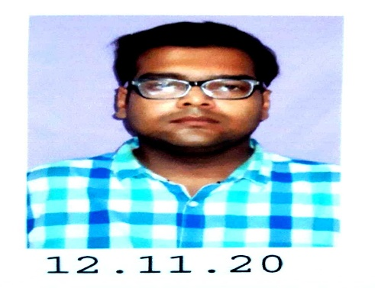
SUMIT KUMAR MAZUMDER
17, Bagmari Lane B.R.S -10 , Block-16 Flat - 33 , Kolkata – 700054
Phone No : 9674230063 Email Id : mazumdersumit711@gmail.com

EDUCATIONAL QUALIFICATIONS
Standard | Percentage of Scored | Board of Examinations | Year of passing
Class – 12 (Science ) | 55% | W.B.B.H.S.E | 2012
Class - 10 | 60% | W.B.B.S.E | 2010

JOB EXPERIENCE
Company Name | Year of Experience | Post Name
Gupta Iron Industries Pvt Ltd | 2 Years | Manager
Kocher Tech Pvt Ltd | 1 Years | Customer Service Provider
Bank of Baroda | 2 Years | Sells Associate

OBJECTIVE
To be associated an organization which gives career path and job satisfaction using my skills.

SKILLS & HOBBY
Basic skills in Computer (MS Office)
Reading, Music & Playing Cricket etc.

PERSONAL INFORMATION
Father’s Name : SANKAR KUMAR MAZUMDER
Mother’s Name : SIMA MAZUMDER
Marital Status : Single
Date of Birth : 24th September 1994
Place of Birth : Kolkata
Religion : Hindu
Caste : General
Language Known : English, Bengali & Hindi
Nationality: Indian
Sibling : Only Sister – PRIYANKA MAZUMDER (Unmarried)
Blood Group : B Positive

Signature

