CURRICULUM-VITAE 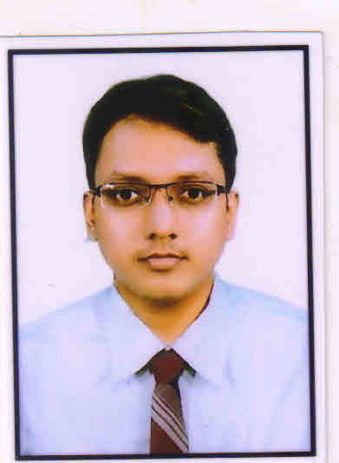

**SOUMIK CHAKRABORTY**

**Contact Details**:

* Rambandh(Near Monimala Math),PO:Burnpur,DT:Burdwan(WB)
* MOBILE - **9851886209/8617012140**
* Email ID - **soumikchak88@gmail.com**

**Objective:**

“My well-founded objective is to associate with a progressive organization that gives me scope to share my knowledge, enhance my skills in accordance with the latest trends, and be a part of team that dynamically works towards the growth of Organization.

**Professional Qualification**

MBA with Marketing specialization from DIMS-DURGAPUR, in 2012 with 66.6% Marks.

**Educational Qualification**

* Passed 10+2+3 from Raniganj institute of information technology(RIIT) under Burdwan University in 2010 in Bachelor of Business Administration(BBA) with 55% marks.
* Passed 10+2 from Santinagar vidyamandir in 2007 in Science stream under WBCHSE with 55% marks.
* Passed 10th from Subhaspally vidyaniketan in 2005 under WBBSE with 61 %marks

|  |
| --- |
| **Work Experience:** |

* **Organization** Rudra Automart pvt.ltd(Authorised dealer of Mahindra

and Mahindra automotive division)

* **Designation**  Showroom sales executive.
* **Posting**  - Asansol (West Bengal)
* **Duration**  - 2012 to june 2019

**Job Responsibilities-**

>Attend customer and provide information of new vehicle. Increase business of new car sales.

>Give product demonstration.(six step demo).

>operate kiosk at showroom premises.

>operate vehicle delivery system, stock check, vehicle Reg.and make cold calls. Enquiry generate through various events and promotional activity.

> Built strong relationship with Customer. Take customer valuable feedback.

> keeping up-to-date products and competitors.

>Customer satisfaction by sorting immediate critical situation.

* **Organisation -** Shriram Auto mall India Limited(SAMIL)
* **Designation -** Senior Executive
* **Posting -** Raniganj
* **Duration -**June 2019 to jan 2020

**Job Responsibilities-**

>Participate in auction process, make customer registration and prepare auction completion report.

>Maintaining and increase business of companys product i.e pre woned vehicle like,LCV,HCV,2W,CARS etc.

>operate vehicle release system, maintain vehicle stock and collect parking charge, service charge and facilitation charge from customer.

>maintaining relation with dealers. Establishing and expanding customer base.

> Make collection of auction/negotiation sold vehicle as per requirement. Collecting customer feedback and market research.

>Dealing with banks and NBFC for collecting NPA stock. Agreement with new buyer.

Follow-ups with existing seller, and make a healthy relationship.

* **Organisation**- Rudra Kia(Dealer of Kia motors )
* **Designation**- Showroom sales Executive
* **Posting**- Asansol
* **Duration**- August 2020 to till now

**Job Responsibilities -**

* Customer meet and gread in showroom,understand their need
* Make presentation and advise the products and solution suiting their needs
* Maintain display of cars in sales outlets and maintain test drive vehicle and fuel Report.
* Walkin customer followup,test drive,booking,Retail monitoring.
* Need to achieve booking ,Retail,test drive target on walkin customer.

**Project Undertaken:**

1. **Project Title : Sales Forecasting of LG Electronics Refrigerator**

30 days training at Burnpur, Asansol area

1. **Summer Internship Project (SIP) at Future Group Retail Ltd, Big Bazaar, Asansol**

60 days training

**Project Title: A study of impact of events on customers purchasing behaviour in Big Bazaar, Asansol vis-a-vis customer perception** .

**Professional Achievement** :Best sales consultant in 2013-14.

Co Curriculum Activities : Completed Diploma in computer operation from Success computer (Burnpur) in the year 2009,(Course Duration-6 Months)

Interest :

* Listen to Music.
* Singing

Personal Details :

* Date of Birth --------08th December, 1988.
* Fathers name ---Mr. Ajoy chakraborty.
* Marital status ------ Married
* Language known --- English,Hindi,Bengali.
* Driving Licence No--WB3720150227652(4 wheeler)

Date---- Signature

Place--- Soumik Chakraborty