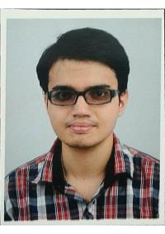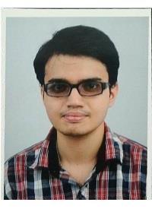

**Name : Rohan Moitra**

**Address : Flat C-9,164/78 Lake Gardens Kolkata 700045,West Bengal**

**Father’s Name: Joydeep Moitra**

**Contact No. : +919007949298,+918981498299**

**E-mail id : rohanmoitra1993@gmail.com**

|  |
| --- |
| **OBJECTIVE** |
| To work with  a dynamic organization and use my knowledge and skills acquired through academics and work experience in the field of Finance & Accounts to contribute to the overall growth of the organization. |

|  |  |  |  |  |  |  |  |
| --- | --- | --- | --- | --- | --- | --- | --- |
| **ACADEMIC PROFILE** | | | | |  | |  |
| **YEAR** | **EXAMINATION** | **INSTITUTE** | **BOARD** | **PERCENTAGE** | | **SPECIALIZATION** | |
| 2017 | CMA(INTER) | ICAI(COST) | N.A | 57.25% | | Professional | |
| 2015 | B.Com (H) | CITY COLLEGE OF COMMERCE AND BUSSINESS ADMINISTRATION | UNIVERSITY OF CALCUTTA | 55% | | Accountancy (H) | |
| 2012 | CLASS (XII) | THE ASSEMBLY OF GOD CHURCH SCHOOL | I.S.C | 78.75% | | Commerce | |
| 2010 | CLASS (X) | THE ASSEMBLY OF GOD CHURCH SCHOOL | I.C.S.E | 61.6% | | N.A | |

|  |
| --- |
| **ASSINGMENTS** |
| * Project on **Online Banking Under University of Calcutta** |

|  |
| --- |
| **SKILLS** |
| * Has handled  following work:  1. Cash & bank entries 2. Preparing Bank Reconciliation statement 3. Supplier bill booking & payment 4. TDS deduction & deposit under Income tax 5. Accounting of GST on suppliers bills & payment 6. Passing Journal entries 7. Finalization of Accounts 8. Preparing various Reports for decision making  * Good Communication * Tally in Accountancy * MS Office, Internet and knowledge of general computer applications. * Team Player |

|  |
| --- |
| **INTERESTS** |
| * Participation in School fests & cultural events * Music |

|  |
| --- |
| **PERSONAL DETAILS** |
| **DATE OF BIRTH :** 12th February 1993  **LANGUAGES KNOWN :** ENGLISH, BENGALI & HINDI.  **MARITAL STATUS :** Single |

|  |
| --- |
| **WORK EXPIERIANCE** |
| * Article Trainee at B. Mukhopadhayay & Co. From August 2017 to March 2018 * Worked at Rama Narayana Education Trust (Narayana School) as Office Coordinator from August 2019 to April 2020 * Working at Quest Properties India limited (Finance Department) since May, 2020 – May, 2021. * Working at Quest Properties India limited (Finance Department) since June, 2021 (under payroll of NMD Placements Consultancy Pvt. Ltd.) |

Signature:

ROHAN MOITRA