**Resume**

**Samir Ghosh**

Vill – Doltala

Post - Samudragarh

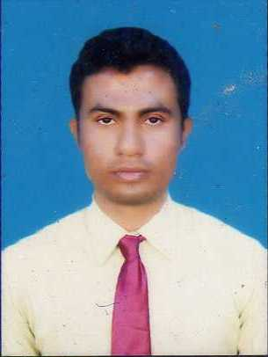P.S- Nadanghat

Pin- 713519

Dist- Burdwan

West Bengal

Contact No.- 9635726433,7047372905.

Email address- **hot.ghosh@gmail.com**

|  |
| --- |
| **Career Objective** |

To contribute to an organization that would help me to utlize my interpersonal communicative, persevering and adaptive qualities that would benefit the mutual growth of the organization and self.

|  |
| --- |
| **Educational Profile** |

|  |  |  |  |
| --- | --- | --- | --- |
| **NAME OF INSTITUTION** | **NAME OF THE EXAMINATION** | **BOARD** | **YEAR OF PASSING** |
| NAWADIP VIDYASAGAR COLLEGE | B.A | THE UNIVERSITY OF KALAYANI | 2010 |
| SAMUDRAGARH HIGH SCHOOL | HIGHER SECONDARY(+2) | W.B.C.H.S.E | 2007 |
| SAMUDRAGARH HIGH SCHOOL | SECONDARY(10) | W.B.B.S.E | 2005 |

|  |
| --- |
| **Professional Qualification** |

I have completed my **“Diploma Course”** from RCLD at Samudragarh. [ office Package, Fox- Pro, Html, Intrenet]

|  |
| --- |
| **Working Experience** |

**\***“ASA INTERNATIONAL INDIA MICRO FINANCE PRIVATE LIMITED”**.** Loan officer 2 years 6 month experience.

* HDFC BANK Credit Officer 3 years 7 month experience .

* L&T finance audit department RCU Executive 1 years 6 Month.

*RBL finserve ltd sr.audit department 1 year 1 month continue.

* Total experience 8 years 8 month Continue SHG & JLG Department, Business Sourcing, Collection, audit & Credit Role from,ASA mfi, HDFC BANK , L&T finance service ltd & RBL finserve ltd sr.audit.

|  |
| --- |
| **Extra Curriculam Activity** |

I have participated in the **West Bengal health training** of one year.

|  |
| --- |
| **Personal Profile** |

•Father's Name : Khudiram Ghosh.

•Date of Birth : 22.02.1988.

•Languages Known : English, Hindi, Bengali (Mother Tongue).

•Nationality : Indian.

•Strength : Adaptable, Co-operative.

•Hobby : Playing Cricket and Listening Music.

**Date - 04/12/2020**  Samir Ghosh

**Signature**

**Place: Samudragarh**