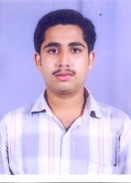

Som Kumar Sarkar
Mob: +919903513845 / 9831998255
E-mail: somsarkar.2009@rediffmail.com & som.sarkar2@gmail.com

OBJECTIVES:

Seeking a challenging position to work in a multinational in a cultural multi skilled
Environment with global presence and interest in emerging markets.As an individual I can learn and gather experience and take my assignment as a challenge.

ACADEMIC QUALIFICATION.
- MBA (Finance) from Sikkim Manipal University in 2014. Secured 51.88%.
- B.Com. (Hons.) from Calcutta University in 2005. Secured 51.63%.
- H.S. from W.B.C.H.S.E in 2002. Secured 62.00%.
- SSC from W.B.B.S.E. in 2000. Secured 61.12%.

WORK EXPERIENCE:
ORGANISATION: SAHARA UTSARGA WELFARE SOCIETY &UTSARGA CHETNA MISSION
DESIGNATION: “SR. OFFICER MIS”
DURATION: June, 2010 to till date.
JOB ROLE: Gained exposure in administrable function of a company with following responsibility:
- Assist to MIS Manager to prepare all type of MIS report.
- Maintain MIS Software all MIS Part.
- Coordinating all the branches with Head Office.
- Assist to purchase department.
- Preparing stock report of the organization.

OTHER ACADEMIC QUALIFICATION:

Tally 9, MS-Ward, MS-Excel, MS- Office from NIIT.
Professional in Accounting & Taxation from "Bengal Tax Counsel”.
Diploma in Computer Application from “INFOCATION”

HOBBY:
- Listening Music.
- Playing Cricket
- Internet surfing.
- Making Friends.

.
BEHAVIORAL CHARACTERISTIC:

- Commitment to Quality and Results
- Responsibility
- Sincere in Attitude
- Presentation and Leadership Skills
- Excellent Problem Solving Skills
_____________________________________________________________________________________

PERSONAL INFORMATION:

Father’s name : Late Bejoy Sarkar
Date of Birth : 23rd May, 1984.
Gender : Male.
Marital Status : Married.
Languages known : English, Hindi, Bengali.
Address : Jagadishpur Hat, Howrah-711115,
West Bengal.

I hereby declare that the above information are true to the best of my knowledge and belief.

Signature
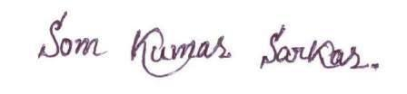
Date: 02/ 03/ 2021
Place: Howrah SOM KUMAR SARKAR

