**RESUME** 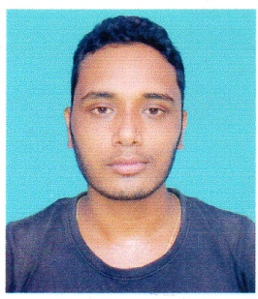

**NAME OF THE APPLICANT : SAMED ALI**

**EMAIL ID : lovesamed123@gmail.com**

**FATHER’S NAME : Samnur Ali**

**PERMENANT ADDRESS : Vill : Karara**

**P.O. : Karara**

**P.S. : Baihata Chariali**

**Dist. : Kamrup (Assam)**

**Pin : 781381**

**PRESENT ADDRESS : -Do-**

**DATE OF BIRTH : 01-03-1992**

**CASTE : General**

**NATIONALITY : Indian**

**COMMUNITY : Assamese**

**RELIGION : Islam**

**SEX : Male**

**MARITAL STATUS : Unmarried**

**EDUCATIONAL QUALIFICATION : B.A. Passed**

**OTHER QUALIFICATION : Diploma in Computer,**

**Computer Hardware & Networking**

**EXPERIENCE : L&T Finance EMI Collector**

**CONTACT NO : 9101382293 / 8135828821**

**LANGUAGE KNOWN : Assamese, Hindi,English**

**DECLARATION**

**I do here by declare that the information given above are true to the best of my knowledge and belief .**



**Date : Signature of the Applicant**

**Place :KARARA**