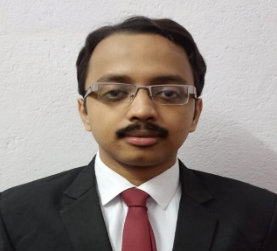

**CONTACT**

**HOBBIES** 



**KEY PROJECTS**

**CAREER OBJECTIVE**

An ambitious MBA degree holder, looking forward to serving in a reputed organization, applying my skills and abilities and further gaining experience and knowledge.

**SAYAN BASU**

**ACADEMIC QUALIFICATION**

|  |  |
| --- | --- |
| * Ultimate Startup Plan | Carried out an unique business idea of fully furnished automated budget homes through recycling materials and thus making it self-automated. |
| * Theme Day | Analysis on Bandhan Bank and its market competitors based on the products market share. |
| * Mutual Fund Event | Detailed study on various investment options in mutual funds of different institutions. |
| * Investment Awareness Camp | Demonstrated the concept of Liquid Market investments through a detailed presentation. |

|  |  |  |  |  |
| --- | --- | --- | --- | --- |
| **Year** | **Examination** | **Institute** | **Board / University** | **Percentage** |
| 2022 | MBA + PGPFM | Bengal Institute of Business Studies | Vidyasagar University | 85.5% |
| 2019 | B.COM (HONS) | City College of Commerce and Business Administration (CCCBA) | Calcutta University | 52.6% |
| 2016 | XII | Apeejay School | CBSE | 62% |
| 2014 | X | Apeejay School | CBSE | 62% |

|  |  |  |  |
| --- | --- | --- | --- |
| **Year** | **Certification** | **Series** | **Certified By** |
| 2021 | Mutual Fund Distributors Certification Examination | NISM VA | NISM |
| 2021 | Investment Adviser (Level 1) Certification Examination | NISM XA | NISM |
| 2021 | Chartered Wealth Manager (Level 1 & Level 2) | - | AAFM |
| 2021 | Online Excel Certificate Course | - | Jaipuria School of Business |

**PROFESSIONAL CERTIFICATES**

|  |  |
| --- | --- |
| Address Icon For Resume #57639 - Free Icons Library | 1, Bihari Lal Chakraborty Lane, Howrah – 711 101 |
| Green phone icon, iPhone 3G Telephone call Computer Icons, phone icon,  text, grass png | PNGEgg | +919836576017 |
| Email Cover Letter Clip Art, PNG, 1667x1667px, Email, Area, Blue, Brand,  Communication Download Free | basusayan63@gmail.com |
| Date Of Birth, Birth, Christmas Icon With PNG And Vector Format ... #591297  - PNG Images - PNGio | 21.01.1999 |

|  |  |  |  |
| --- | --- | --- | --- |
| Music Free Icon of Button UI - Alt System Folders Icons | Music | Free cricket logo - Vector Art | Cricket |
| Travel Logo Vector Images (over 210,000) | Travel | Blue, circle, book, bookmark, education, favorite, learn icon - Download on  Iconfinder | Reading |

**CURRICULUM VITAE**