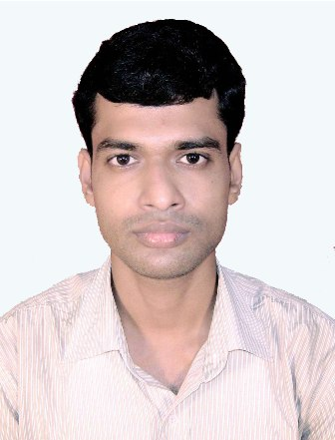

Misbapur, Lakshmipur, Purbasthali, PurbaBardhaman, Pin- 713512

**Sk Golam Mahiuddin**

**M Com &MBA in Finance &Accounts with 3 years experience in Financial Analysis and Accounts**

To perform job in any situation and any environment by efficiency and sincerity for the good of the organization and its environment.

**WORK EXPERIENCE**

* **Accountant**

**Brahmanagar S.K.U.S. Ltd.(Samabay Bank) Nadia**

***02/2020 – Present***

***Achievements/Tasks***

* Accounting activities and Internal Audit
* Credit Analysis and Loan Disbursement
* Daily Banking Activities
* **Vocational Trainer**

**Sibin Group (Banking &Finance) South 24 pgns.**

***03/2018 – 02/2020***

***Achievements/Tasks***

* Vocational Class and Soft-skill Class
* **Research Analyst**

**Gyan Research & Analytics Pvt. Ltd Kolkata**

***03/2016 – 02/2018***

***Achievements/Tasks***

* Financial Statement Analysis and Evaluation
* Ratio Analysis
* Projections
* Valuation
* Excel Work
* Report Writing
* **Subject Matter Expert**

**ABSAS Solutions Pvt. Ltd Kolkata**

***02/2015 – 02/2016***

***Achievements/Tasks***

* Financial Analysis
* Excel Work
* Report Writing
* **Back Office Executive cum Accountant**

**Global Industries Kolkata**

***01/2014 – 09/2014***

***Achievements/Tasks***

* Official and Administration Work
* Basic Accounting

**SKILLS**

**INTEREST**

**LANGUAGES**

14th January, 1991

9932209300/8910000270

skgolam1991@gmail.com



**Financial Analysis, Accounting, Administrative& Tally**

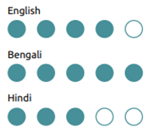

**EDUCATION**

* **M.Com.**

**Asutosh Study Centre (DDE-Vidyasagar University)**

***2016 – 2018***

***Percentage/Grade***

* 48 percent
* **MBA in Finance**

**Brainware Group of Institutions (WBUT)**

***2011 – 2013***

***Percentage/Grade***

* DGPA 6.97
* **BBA in Finance &Accounts**

**AMEX (Burdwan University)**

***2008 – 2011***

***Percentage/Grade***

* 67 percent
* **HS (Higher Secondary)**

**Katwa K.D.I. (W.B.C.H.S.E.)**

***2008***

***Percentage/Grade***

* 64 percent
* **Madhyamik (Secondary)**

**Katwa K.D.I. (W.B.B.S.E.)**

***2006***

***Percentage/Grade***

* 68 percent

**PROJECTS**

• A market survey and study on the customer and media behavior in different markets of Bihar and U.P with regard to EmamiNavratna Cool Oil and its competitors. (MBA Internship Project)

• A study regarding the performance of Bharati AXA with special reference to the company performance. (MBA Summer Internship Project)

• Some aspects of Liquidity, Profitability and Non-insurable risk: A case study of Burnpur Cement Ltd. (BBA)

**PERSONAL DETAILS**

**Father’s Name:**Kasem Shaikh **Marital Status:** Single **Gender:** Male **Nationality:** Indian **Blood Group**: O+

**TECHNICAL SKILLS**

**IT Skill:** MS Office, Internet and Basic Computer

**DECLARATION**

I hereby declare that the above statements and information are true and proof of the same will be furnished whenever required.

Date: Signature

Place: