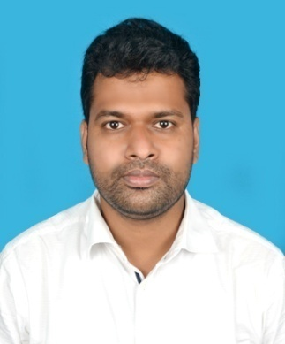

Misbapur, Lakshmipur, Purbasthali, PurbaBardhaman, Pin- 713512

**Sk Golam Mahiuddin**

**MBA & M Com in Finance & Accounts with experience in Credit Manager**

To perform job in any situation and any environment by efficiency and sincerity for the good of the organization and its environment.

**WORK EXPERIENCE**

* **Credit Manager (DMII)**

**ICICI Bank Kolkata**

***03/2022 – Present***

***Achievements/Tasks***

* Credit Underwriting of BLG
* Credit Analysis and Loan Disbursement
* Loan sanction as per policies guideline and maintaining TAT

Working capital facilities Fund based (OD, CC, DLOD and Term Loan) and Non Fund Based (BG and LC)

* **Accountant**

**Brahmanagar S.K.U.S. Ltd. (Co-operative Society, PACS) Nadia**

***02/2020 – 03/2022***

***Achievements/Tasks***

* Accounting activities and Internal Audit
* Credit Analysis and Loan Disbursement
* Daily Banking Activities

Banking Products: Vehicle Loan, Loan against Deposit, Loan against NSC/KVP, House Building Loan, Non-farming Loan and CC Loan

* **Vocational Trainer**

**Amratala Gonsaidas High School under Sibin Group South 24 pgns.**

***03/2018 – 02/2020***

***Achievements/Tasks***

* Vocational Training
* **Research Analyst**

**Gyan Research & Analytics Pvt. Ltd Kolkata**

***03/2016 – 02/2018***

***Achievements/Tasks***

* Financial Statement Analysis and Evaluation
* Ratio Analysis
* Projections
* Valuation
* Excel Work
* Report Writing
* **Subject Matter Expert**

**ABSAS Solutions Pvt. Ltd Kolkata**

***02/2015 – 02/2016***

***Achievements/Tasks***

* Financial Analysis
* Excel Work
* Report Writing

**SKILLS**

**INTEREST**

**LANGUAGES**

14th January, 1991

9932209300/8910000270

skgolam1991@gmail.com



**Financial Analysis, Accounting, Administrative& Tally**

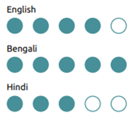

**EDUCATION**

* **MBA in Finance**

**Brainware Group of Institutions (WBUT)**

***2011 – 2013***

***Percentage/Grade***

* DGPA 6.97
* **M.Com.**

**Asutosh Study Centre (DDE-Vidyasagar University)**

***2016 – 2018***

***Percentage/Grade***

* 48 percent
* **BBA in Finance & Accounts**

**AMEX (Burdwan University)**

***2008 – 2011***

***Percentage/Grade***

* 67 percent
* **HS (Higher Secondary)**

**Katwa K.D.I. (W.B.C.H.S.E.)**

***2008***

***Percentage/Grade***

* 64 percent
* **Madhyamik (Secondary)**

**Katwa K.D.I. (W.B.B.S.E.)**

***2006***

***Percentage/Grade***

* 68 percent

**PROJECTS**

• A market survey and study on the customer and media behavior in different markets of Bihar and U.P with regard to Emami Navratna Cool Oil and its competitors. (MBA Internship Project)

• A study regarding the performance of Bharati AXA with special reference to the company performance. (MBA Summer Internship Project)

• Some aspects of Liquidity, Profitability and Non-insurable risk: A case study of Burnpur Cement Ltd. (BBA)

**PERSONAL DETAILS**

**Father’s Name:** Kasem Shaikh **Marital Status:** Married **Gender:** Male **Nationality:** Indian **Blood Group**: O+

**TECHNICAL SKILLS**

**IT Skill:** MS Office, Internet and Basic Computer

**DECLARATION**

I hereby declare that the above statements and information are true and proof of the same will be furnished whenever required.

C:\Users\ABCD\Downloads\sig.jpg

Signature