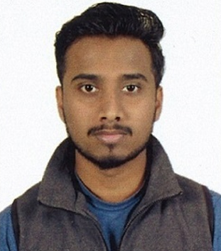

**SK. RASEKH AHMED**

**Permanent Address**: **D No.-17/2/H/11, Smith Lane, Kolkata-700013**

**E-Mail**: **skrasekh786@gmail.com**

**Phone No: +91 9330720958 / 9748185130**

**PROFESSIONAL SUMMARY:**

* An Effective Team Member with proven qualities & productivity.
* Ability to Multi-task & finish work within deadlines.
* Responsible team member & flexible in working with or without supervision.
* Desired to work in a healthy environment and prove my abilities.
* Honest, Punctual and Hard Worker.

**EMPLOYMENT SCAN:**

* Worked as an HR recruiter and Admin Executive at Yes Tech Solution Alipore from Sep 2017 to Feb 2018.
* Worked in 123 Home paints as an Account Executive from March 2018 till January 2020.
* Presently working in Kolkata Response Group as an Account Assistant from 1st June 2020.

**KEY RESPONSIBLITIES HANDLED:**

* Enter posting of purchase, sales, payment, receipt collection & journal voucher.
* Verification of bills & reconciliation of total turnover.
* Bank, Debtors & Creditors Reconciliation.
* Maintain cash transaction & petty cash book, preparing cash.
* Day to day cash & bank transactions.
* Preparing outstanding list of Debtor & making Payment follow-up.
* Preparing of Tax invoices, Vouchers & Agency Payment.
* Sales & Purchase total reconciliation of accounts.
* Also maintain office correspondence work.

**KEY RESPONSIBLITIES HANDLED:**

* Resourcing candidates from different sites like Indeed, Monster and Work India.
* Calling the candidates and fixing up an interview for different clients as per profile required
* Responsible for end to end recruitments.
* Keeping a track of the candidates and sending report every day.
* Handled PF, ESCI for the staffs.
* Responsible for filing PF and ESIC for the staff.
* Handled staff grievance.
* Handled Admin related work as Job monitoring, office assets maintenance & supervising

**EDUCATIONAL QUALIFICATION:**

* B.com under Calcutta University.
* 12th under I.S.C from ST. Helen School.
* 10th under I.C.S.E from Shatavisha Public School.

**CERTIFICATES/APPRECIATIONS:**

* Computer knowledge in windows
* MS Office 2007( Word and Excel)
* Tally ERP9
* Internet proficiency
* GST E-filling and return
* CFA

**PERSONAL INFORMATION:**

Date of Birth: 10th July 1995

Marital Status: Single

Maiden Name: Ahmed

Nationality: Indian

Language Known: English, Hindi, Bengali

**Place- Kolkata**

