Name : Somnath Dawn 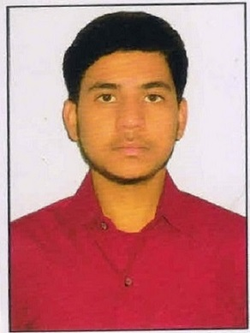
Address : South Ranitala , Mahato Para , Kulti , Paschim Bardhaman , Pin - 713343
Mobile No : 8927539964

E-mail : somnathdawn2468@gmail.com

Academic Qualifications:

Degree / Certificate | Degree | Discipline | Institute | Board /  University | Year of Passing | Aggregate % / CGPA
Graduation | BTECH | COMPUTER SCIENCE & ENGINEERING | Asansol Engineering College | MAKAUT | 2020 | 8.0 DGPA
12th | HS | SCIENCE | Smt Ginia Devi Modern School | CBSE | 2016 | 72.50%
10th | SS | GENERAL | Smt Ginia Devi Modern School | CBSE | 2014 | 8.8 CGPA

PROJECT

TITLE : --
ONLINE FOOD ORDER IN CANTINE

Description :-- This is web application project which is developed in java by servlet programming .

Front End :-- HTML
Database :-- ORACLE SQL (10g)

TITLE : --
Vechile Booking Application by implementing Blockchain

Description :-- This is computer application software where customer can book a Vechile.
Blockchain Concept is been used so no center server is present. Processing is done in Distributed
& decentralized way. By Python programming project is developed.

Front End :-- Tkinter (Python)
Database :-- SQL Light (to store smart contact) , File System ( to store Ledger )

TECHNICAL SKILLS

PROGRAMMING LANGUAGE :--
- JAVA
- Python
- C/C++
- SQL

SUBJECT INTERESTS

- Programming in Java/Python/C/C++
- Data Structure
- Operating System
- Computer Networking
- Database Management System
- Design & Analysis of Algorithim

Certifications :--
- Programming in C++ from NPTEL ( in 2018 )
- Agile Foundation using Jile from TCS iON ( in 2019 )
Achievement :--
- GATE 2021 QUALIFIED
- Gold medal in Joy Of Computing Using Python from NPTEL
- TCS CODEVITA Season 8 QUALIFIED

Hobbies:
- Computer Programming
- Playing Football

Personal Details :

Date of Birth : 08/12/1997
Gender : MALE
Languages Known : English (read, speak, write) , Bengali (speak) , Hindi (speak)
Aadhaar No : 537101661259

Date : 20/3/2021

Signature -----------------------------------------------

