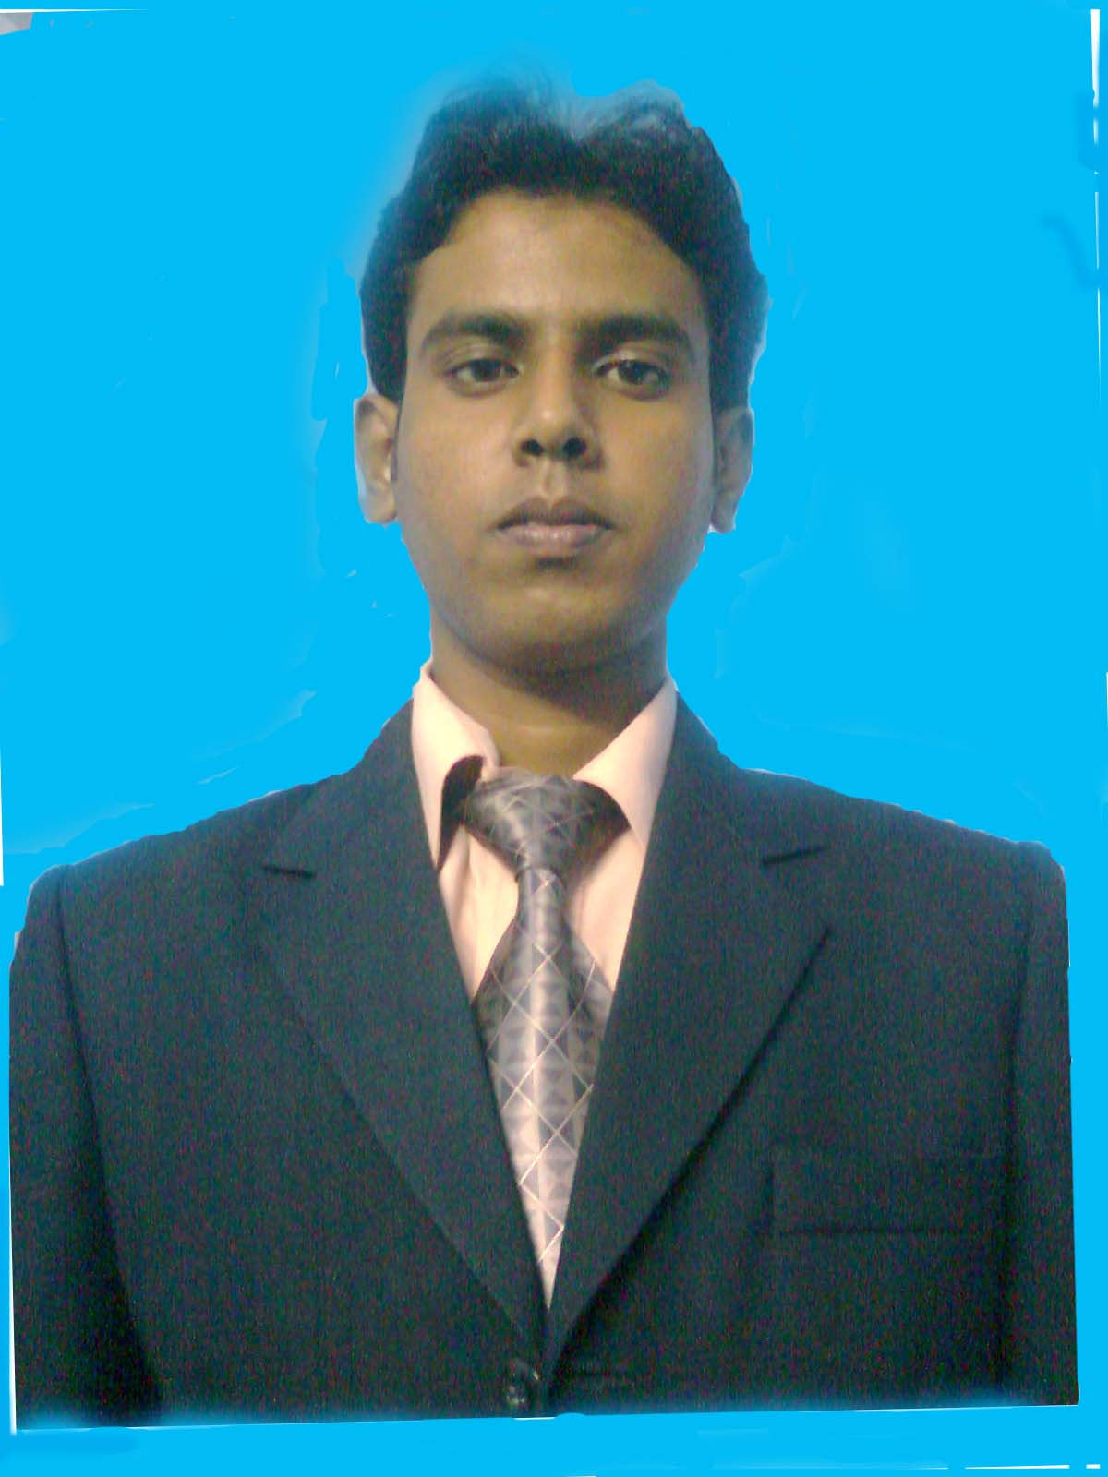

CURRICULUM VITAE

Mr. Soumadip Das

CAREER OBJECTIVE:
I am outgoing and energetic young professional, seeking career that fits my professional skill. I can leverage my knowledge and skills to bring out favorable outcomes for your esteemed organization/firm.

Soumadip Das  House no-40, Lane-2, Nabodit, Nayabad,  P.O- Mukundapur, Kolkata- 700099. | Email address: dip27das@gmail.com  Contact No: 8336069469

Working Experiences:
- Last Company : As Sales Executive at Borosil Glass Works Ltd.
Area: Kolkata Part, South 24 parganas and South Bengal ( Burdwan East , Burdwan West,
Purilia, Bankura ----From Middle of April 2019 to till Middle of January 2020.

Role & Responsibilities:
- Managing the Distributors – By way of making Primary Regular basis as per Target.
- Making plan for Secondary plan Dealer wise and also Bit wise.
- Making the plan for Collection .
- Market Research and market mapping to understand market opportunity and threats for
the Products and other Companys products.

- SWOT analysis and Data analysis for preparing a proper market plan and Implementation it with the team or Teams.
- Interact with many customers to solve the problem regarding Customer Complain related to Appliances and other Product also.
- Frequently Visit Dealer Shop in every month in BIT wise
- Demand Generation by frequently hammering about the products & Latest Schemes to the Dealer & Make them aware to get the maximum benefit for their benefit.

2. Previously working as ASO at ELKOM ENTERPRISE PVT. LTD
(HAWKINS DIVISSION) (From May 2016 to March 2019)

Market Area: Burdwan East & Burdwan West, Bankura, Purulia, Birbhum.

Role & Responsibilities:
- Market Research and market mapping to understand market opportunity and threats for the Products and for new marketed products.

- SWOT analysis and Data analysis for preparing a proper market plan and Implementation it with the team.
- Awareness creation and awareness raising by direct interact with the Dealer & Indirect Dealer.HAM, HAW, HAR & ODD, New Dlr.
- Interact with many customers to solve the problem
- Frequently Visit Dealer Shop in JCs.
- Demand Generation by frequently hammering about the products & Latest Schemes to the Dealer & Make them aware of Conference Point keeping good relation with Dealer to get better result for demand generation. Development of Sales and bottom line.
- Payment collection, Remind them Due date.
- Regular Visit at Modern Trade Shops to maintain Display, Collect the stocks level, solving and guide the concerned person for any complains.

Previous Working Experiences:
- Akzo Nobel India Ltd. [ From January 2015 To April 2016]
Designation: Customer Relation Officer.
Roles & Responsibilities: Demand generation by way Secondary Sales and simultaneously
Make the primary

2) Medi Surg ----- A Medicine Distributor Firm. [ From April 2014 To January 2015]
Designation: Sales Coordinator.
Roles & Responsibilities: Generate the Institution Sales.

- Sankara Nethralaya [From May 2012 to March 2014]
Designation: Guest Relation Executive.
Place: Kolkata
Roles & Responsibilities: Counseling of patient and make them convinced to take the
Premium services of the Hospital.

- S.Ghosh & Company ( A Chartered Firm)- From June 2011 To January 2012 .
Designation: External Auditor.
Roles & Responsibilities: To visit various public and private organizations such as
--Johnson &Johnson,
--Allahabad Bank (forex dept. Mumbai),
--RBI Kolkata Syndicate Bank For concurrent and statutory audit.
QUALIFICATIONS: PROFESSIONAL QUALIFICATION:
Master in Business Administration (MBA Full Time)
Year: 2008-2010 (Marketing & Finance)
Institution: Department of Management, University of North Bengal, Darjeeling.
Percentages of marks: 73.38
Certificate in Computer Application :
Tally 7.2, Excel , Word, Power Point .
ACADEMIC QUALIFICATIONS:
-----------------------------------------------------------------
Bachelor of Commerce (B.Com honours) Year:2003-2006
Institution: South City College Under University of Calcutta.
Percentage of Marks: 66.5

Higher Secondary (10+2) : Year: 2003
Jadavpur High school
Percentages of marks: 60.5

Secondary Examination (10th) : Year: 2001
Jadavpur High school
Percentage of marks : 70

PROFESSIONAL TRAINING:

1) Project : Performance of Mutual Funds in India.

Company : R.J. Seth & Company--- A Share Broking Firm.

2) Training : Big days of Big Bazaar (Certificate of Future value retail limited).
Company : Pantaloons Retail (India) Limited
Position : Management Trainee.

Technical skill
- Certified in Information Technology from University of Calcutta.
- Knowledge on windows operating system (from windows98-vista).
- Knowledge on Office Packages (from 2000-2007).
- Knowledge on Tally9 (Accounting software)

PERSONAL DETAILS:

Fathers Name: Late Dhirendra Nath Das
Mothers Name : Mrs. Bithika Das (House Wife)

Date of Birth: 27th Feb, 1985
Sex: Male
Martial status: Single / Unmarried

Language Proficiency: English (W/R/S), Hindi (W/R/S), Bengali (W/R/S)
Communication Address: House no-40, Lane-2, Nabodit,
Nayabad , Po- Mukundapur
Kolkata-70009
HOBBIES:
- Listening music
- Travelling
- Photography

DECLARATION:
I hereby declare that all the information furnished by me in this application is factual and correct to the best of my knowledge and belief.

Soumadip Das
Date: / 0 / 2021

