**Contact**

**Address:**

C/o Prasanta Pal

89/45 Rabindrapally,Netaji Road,Barrackpore,N:24 Pgs

Kolkata -700122

Westbengal

**Phone:**

+91-9143198297/6289199503

**Email:**

sabyasachi.majumder[@gmail.com](mailto:christoper.m@gmail.com)

Date Of Birth : 29/12/1987

Languages

Bengali - Read,Write,Speak

English - Read,Write,Speak

Hindi - Speak

Hobbies

* Play Cricket,Batbinton
* Listen Music
* Home Work

**SABYASACHI MAJUMDER**

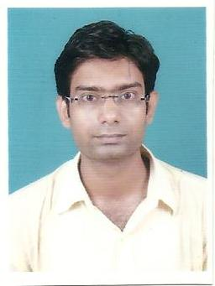

Objective

In pursuit of a career in the industry that recognize & appreciates my Experience & ability in 7 years..

**Skill Highlight**

|  |  |
| --- | --- |
| √ Project management  √ Strong decision maker  √ Problem solver | √ Innovative  √ Service-focused |

**Experience**

**Office Manager** : 10/2018 to 12/2020

IBS Hooghly,Hooghly

• Overall Management Functions Of Organization.

• Organize,Plan & Execute Office Management Strategies.

• Manage Staff ,Employee Relationship.

• Relationship Management WithEmployee & high Authority

• Official Work etc.

• Counselling,Relationship

**Computer Faculty** : 06/2015 to 09/2018

George School Of Competitive Exams,Unit Of George Telegraph

• To Teaches Computer as Subject.

• Maintained Relationship With Students.

• Content Writer in GSCE Magazine "Achievers in focus"

**Associate** : 09/2013 to 03/2015

HCL Infosystem Limited

• To Coordinator with School Authority & Company's Digischool Projects..

• Relationship With Customer & Company.

**Education**

**Bachelor Of Technology :** Computer Science & Engg.

Future Institute of Engg. & Management,Sonarpur,Kolkata

Year : 2010-2013

**Dipolma Of Engineering** : Computer Science & Technology

Dumakal Polytechnic,Dumkal,Murshidabad

Year : 2006-2010

**Higher Secondary** : Science

Prafullanagar Vidyamandir

Year : 2004-2006

**Secondary** :Habra High School

Year : 2001-2003

**Technical Course** : Diploma In Hardware &Software Maintenance.

Barrackpore Youth Computer Centre.

Year : 2010-2011

Date:

Place:

Signature