Curriculum Vitae
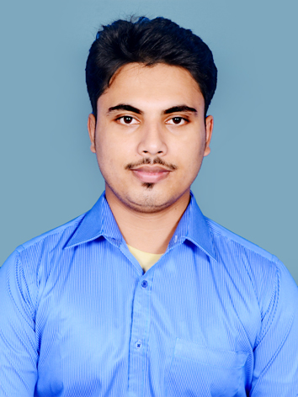

Name : SUBHAMOY BANERJEE
Address :AT-VILL:BB COLONY,PO- NAYASARAI, P.S-MOGRA, DIST-HOOGHLY (WB),PIN-712513
Mobile No :+91 6289039563,+91 8583918189

E-mail :sbhmybnj@gmail.com, subhamoy.b20@licindia.com

Qualification : B. Tech (Mechanical Engineering)

Career Objective: Want to excel in the field of work wherever I get the opportunity to serve.

Academic Qualifications:

Degree/Certificate | Institute | Board/  University | Year of Passing | Aggregate % / DGPA
Graduation  (B. Tech) | JIS College Of Engineering,  Kalyani, Nadia. | MAKAUT/Formerly (WBUT) | 2017 | 7.95/72%
12th  (Higher Secondary) | BANDEL ST.JOHNS H.S. | WBCHSE | 2012 | 64.2%
10th  (Madhyamik) | GOWA ZIAUL HAQUE INSTITUTION | WBBSE | 2010 | 68.4%

Vocational Training/Projects

Name of the organization | Projects Undertaken | Duration
Hindustan Aeronautics Ltd.(Min. Of Defence) | Brief study of Chetak & Cheetah helicopters. | Four weeks
Kesoram Rayon Industry(BK Birla Group) | Viscose Filament Yarn & Production of Textiles | 1 month

WORK EXPERIENCE
- Worked in UNITED CEMENTS PVT.LTD.(KL DUGGAR GROUP,NEPAL) as a GET for 6 months.
- Presently working in LIC as a Development Officer from 1.6 years (Marketing and Risk assessment).

Job related and Technical Skills

- Deep knowledge of insurance industry and leadership skill of leading agents to achieve their targets.
- Critical thinking and underwriting of different life insurance policies.
- Knowledge of banking industry and banking related things.
- Technical knowledge in my domain and Basic knowledge of MS office suite, Internet applications, Basic knowledge of ‘C’ Programming, MS EXCEL.

Extra curricular Activities

- Participated in the seminars and conferences.

ACHIEVEMENT
1. Selected as a Micro Observer officer in the 2021 WB Assembly Elections.
2. Scored more than 90 percentile in the AMCAT exam.

Personal Details:

Father’s Name : SANDIP BANERJEE
Mother’s Name : CHAMELI BANERJEE
Nationality : Indian
Hobbies : Watching political debate shows, learning about different countries capital’s and currencies, reading about current affairs and playing outdoor games.
Date of Birth : 25/05/1994
Gender : Male
Languages Known (Read, Write and Speak) : English, Hindi, Bengali

Declaration:
I hereby declare that all the information furnished above are correct to the best of my
knowledge and belief.

Place:- Nayasarai.
………………………………
Date:- 22/04/2021 Signature

