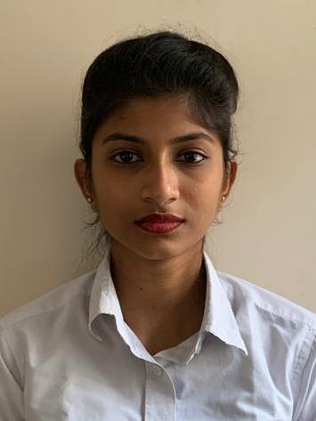CURRICULUM VITAE

***TIYASHA DAS***

PH: (+91) 7003893491

E-Mail :dastiyasha03@gmail.com

#### *CAREER Objective*

To see myself as a successful corporate personnel in a renowned brand, within the forthcoming five years henceforth.

#### *Proficienc*y

* **In order strive and achieve my goal, I feel that I have the following qualifications :**

To work diligently and sincerely under pressured atmosphere for a long period of time.

Have command over my language and thus can communicate well with all sections of the society.

***PROFESSIONAL QUALIFICATION***

|  |  |  |
| --- | --- | --- |
| **YEAR OF PASSING** | **QUALIFICATION** | **BOARD/UNIVERSITY** |
| 2016 -2019 | Passed Bachelor In Hospital Management | From Indian Institute of Hotel Management(IIHM) under Singhania University |

#### *PROFESSIONAL EXPERIENCE*

* At present working in **Medica Superspecialty Hospital, Kolkata** as Guest Relations Associate since 17th October 2019**.**
* Previous working as a Front Office Associate since 6th September2018 in **Space Circle** **Clubs & Resorts.**

#### *INTERNSHIP*

* I have done 6 Months BHM Internship in In-Patient in **AMRI HOSPITAL,**MUKUNDAPUR.

***RNSHIP***

#### *ACADEMIC Credentials*

|  |  |  |  |
| --- | --- | --- | --- |
| **YEAR OF PASSING** | **QUALIFICATION** | **BOARD/UNIVERSITY** | **INSTITUTION** |
| 2016 | Higher Secondary | W.B.C.H.S.E | Dum Dum Kumar Asutosh Institution |
| 2014 | Madhyamik | W.B.B.S.E | Dum Dum Road Govt. Sponsored Girls High School |

#### *EXTRA CARRICULAR ACTIVITIES*

|  |  |  |  |
| --- | --- | --- | --- |
| **YEAR OF ISSUE** | **ACTIVITIES** | **CERTIFICATE HOLDING FOR** | **GRADE** |
| 2016 | Computer Basic Course | WBSCT & Vocational Education & Skill Development | A |

#### *HOBBIES*

* Always eager to Search Latest Cosmetics collections.
* Testing of various cuisines, as I am foodie.
* Interact with new people and make new friends.

#### *STRENGTH*

* I am task driven and Integrity, Commitment, Passion are my major strengths.

#### *Weakness*

* I do not like persons who do not keep their commitments.

#### *linguistic abilities*

|  |  |  |  |
| --- | --- | --- | --- |
| **LANGUAGE** | **READ** | **WRITE** | **SPEAK** |
| ENGLISH | YES | YES | YES |
| HINDI | - | - | YES |
| BENGALI | YES | YES | YES |

***PERSONAL INFORMATION***

Father’s Name : Mr. Nisith Kumar Das

Father’s Occupation : Employee of Kolkata Port Trust

Mother’s Name : Mrs. Rani Das

Mother’s Occupation : Home Maker

Date of Birth : 30-10-1998

Age : 23 Years

Marital Status : Single

Religion : Hinduism

Nationality : Indian

Height : 5'3"

Sex : Female

Residential Address : 5/6, Seth Bagan Road (Dum Dum), Kolkata-700030

#### *DECLARATION*

I believe to the best of my knowledge that the above mentioned data and information submitted are true and correct.

***Signature_final.JPGDATE : 06.08.2021***

***PLACE : KOLKATA TIYASHA DAS***