Tuma Banerjee  Mobile: +91-8777487116  E -mail: tuma1975@gmail.com | 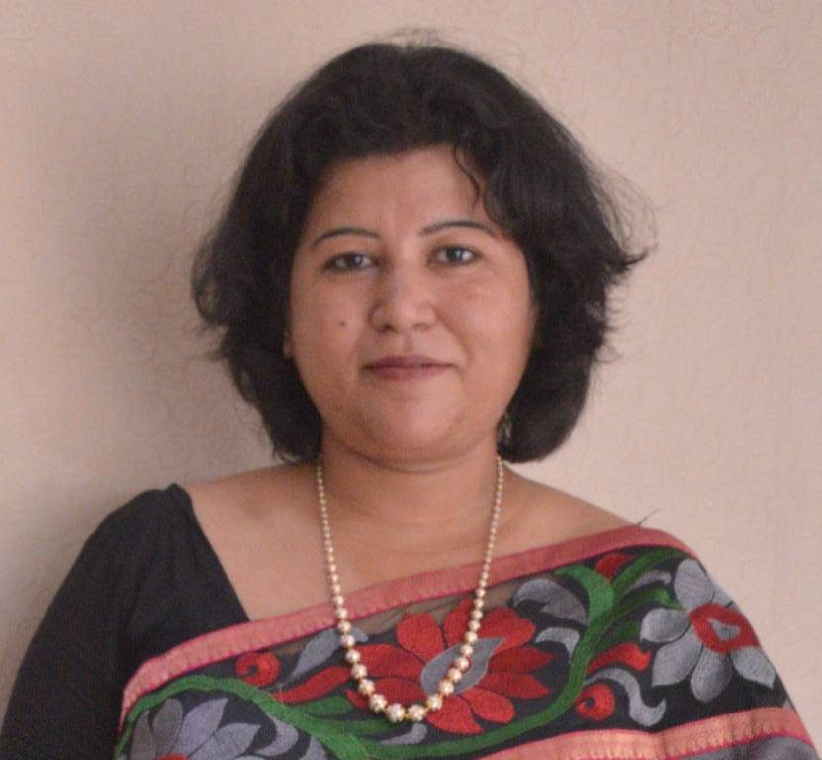

CAREER OBJECTIVE
To work for an organization that gives me ample scope to apply my knowledge and nurture my skills thus helping me to become a successful professional and a valuable asset for the organization
WORK EXPERIENCE
Working in a Logistics Company since Dec,23
Working in KOTAK LIFE as Senior Advisor from August,23. IRDAI Approved Advisor
Worked in an Education institution as Director of two colleges (Polytechnic and Hotel/Media/ Travel Tourism (College) since November,2016 till October,2018..
Solely responsible for college activities like HR, Maintenance, Administration, Examination & Marketing

Worked in a PSU under Ministry of Steel as Senior Officer ( Coordination) since March,2016 till October,2016..
- Preparation and issue of initial appointment letters to selected candidates.
- Issue of deployment orders to agencies.
- Initiation and processing contract renewals of personnel.
- Extension and increment of remuneration of personnel deployed by outsourcing agencies
- Processing of bills of outsourcing agencies.
- Organizing conference, events, official picnics and get together.
- Transport & hiring vehicles, train and air reservations.
- Managing guest house, facility management, mobile and other facilities to employees including processing of bills.
- Other administrative duties.
- Imp rest Holder for Administration Department

Worked in a PSU under Ministry of Steel as Executive Secretary to CMD and Incharge Administration since August,2010 till February,2016 .
- Secretarial Job
- Coordination with all units
- Arranging meeting with Minister’s, Secretaries and Joint Secretaries.
- Travel Arrangement for Chairman and Managing Director including abroad [arranging Visa].
- Handling CMD’s visitors.
- Maintaining CMD’s personal file.
- All office administration work including office requisitions, cash handling, logistics, transportation, executing agencies and office reports arranging for CMD.
- Handling staff welfare matters.
- Feedback handling.
- Imp rest Holder for Administration Department.

Worked in Pailan Group as General Manager T&P since Nov,09 to July,10 in a Group of Educational institution.
- Meeting corporate
- Arranging Campus/ Off Campus Interview for Post Graduates & undergraduates
- Students Counseling
- Arranging Projects & SIP for Master & Bachelor degree students
- Arranging soft skill training for students followed by placements
- Find & recruit Consultants and tie ups

Worked in a Pailan Group of Institutions as OFFICER INCHARGE – ACADEMIC DEVELOPMENT, MARKETING AND INTERNAL ADMINISTRATION from July,2004 to April,09
- Faculty & Staff recruitment
- Solely responsible for college activities like HR, Maintenance, Administration, Examination & Marketing
- Students Advisor & Career Counselor after admissions.
- Looking after the students and staff matters.
- Policy decisions in consultation with Chairman
- Involved in infrastructure Planning
- Officer In charge designated by University for Examination
- Into the approval process of new institutions of Engineering, PGDM, MBA & MCA courses as per WBUT & AICTE
- Involved in academic development of the institution.

Worked in MCKV INSTITUTE OF ENGINEERING as In Charge HRD and Coordination from August’1999 to June’2004.
- Counseling & Admission of students
- Preparing Director’s Report, which is used in Governing Body Meetings
- Preparing presentations
- Monitor institute’s website
- Member of Management Review Committee
- Data Analysis of different Departments
- Organization’s internal auditor
- Involved in infrastructure Planning
- Prepare MIS Report
- Taking policy decisions in consultation with respective HODs & In-charges
- Involvement in purchase section, store, consumable store

Worked as Receptionist one year in B.M.Birla Heart Research Institute September 1998 to July,1999.
- Handling Patients parties and looking after their bookings.
- Looking after the patient’s requirements at ward.
- Prepared daily report for Administrator.
- Preparation of monthly roster of Receptionist at the Hospital.
- Patient Support

Worked two years as Placement Executive in APTECH Ltd. (North Calcutta )
- Looking after the student’s placement.
- Visiting clients place.
- Arranging for Campus Interview.
- Counseling students regarding Aptech Course
- Monthly Meetings and reporting to Regional Head

Worked as Student Liaison officer in APTECH Ltd.(Vadodara)from May 1996
- Liaison with students regarding fees, counseling after admission, issuance of required official documents.
- Liaison with management regarding student’s requirement, problems and others matters.

ACADEMIC CREDENTIALS
Board / Examination | School / College & Board | yGPA/ Percentage | Year of passing
Master of Business  Administration [HR] | St. Xaviers College under  Indira Gandhi National Open University | Ist Div with Distinction | 2005
Bachelor in Commerce | S.P.Jain College  (Ajmer University) | 2nd Div | 1996
Higher Secondary | Kendriya Vidyalaya  CBSE Board | 2nd Div | 1993
Secondary | Kendriya Vidyalaya  CBSE Board | 2nd Div | 1991

PROFESSIONAL QUALIFICATION
Completed 1 ½ years course Higher Diploma in Software Engineering from Aptech Ltd.

SPECIAL INTEREST
- Travelling
- Cooking
- Counselling

PERSONAL DETAILS
- Date of birth : 14th September, 1975
- Present Address : 61 Shambhunath Pandit Street
Kolkata - 700025
- Languages Known : English, Hindi, and Bengal

Date :
Place :
Signature :

