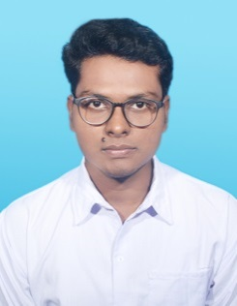**RESUME**

Name : SUBHAJIT BAIDYA

Contact No. : 9007415952

Email : subhojit9923@gmail.com

***Career Objective*** *:*

***To obtain a responsible position that will allow me to utilize my skill, hardworking and willingness to learn and grow with the company and be a part towards company’s growth and success.***

**EDUCATIONAL QUALIFICATION**

|  |  |  |
| --- | --- | --- |
| **NAME OF EXAMINATION** | **BOARD/ UNIVERSITY** | **SCHOOL/COLLEGE** |
| B.Com (Marketing) | Calcutta University | Prafulla Chandra College |
| Higher Secondary | W.B.C.H.S.E | Tirthapati Institution |
| Secondary | W.B.B.S.E | Surendra Chakraborty Institution |

***Projects*** *:*

* ***Hospitality Management***

***DESCRIPTION : completed six months certificate programme from NIPS School Of Hotel Management (National Skills Development).***

***KEY SKILLS : Commi’s Chef***

* ***Seamanship training :***

***DESCRIPTION : completed four months certificate programme from Sea Explore Institute Kolkata.***

***KEY SKILLS : Basic navigation first aid, life saving and rescue programme, Boat pooling, voyages.***

***Technical Skills*** *:*

* ***Completed financial accounting system 1 (one) year diploma from Youth Computer Training Centre (Govt. of West Bengal).***

***Achievement*** *:*

*Because of my strong inter personal and healthful mentality, I was form a team with my friend and we health the* ***Sunderban Areas People,*** *who are mostly effected for* ***“Aamphaan”.***

*For many people contribution and with the help of trust we supplied food to the many poor people during lockdown of* ***COVID-19.***

*I selected in the* ***Water Balley Team*** *organized by* ***ILSS.*** *We are only team in India who are played* ***Water Balley*** *in the dramatic song****.***

**PERSONAL VITAE :**

Father’s Name : Mr. Shyamdeb Baidya

Date of Birth : 20.05.1996

Address : 12D, Dover Terrace, Kolkata – 700029, W.B..

Nationality : Indian

Languages known : Bengali & English can read, write & speak, Hindi (only speak)

Hobbies : Travelling, listening song.

Strength : Positive attitude effective presentation, Smart working, crisis management.

**DECLARATION**

I hereby declare that the above information given is true to the best of my knowledge and belief.

Date:

Signature

