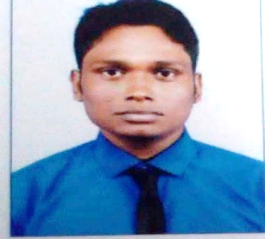**SUJIT ROY**

**Mahendranagar, Natagarh, North 24 parganas, kol – 700113**

**7595992834 |** [**sujitr744@gmail.com**](mailto:sujitr744@gmail.com)

# CAREER OBJECTIVE

**Hard-working employee with proven leadership and organizational skills, and minute attention to detail. Seeking to apply my abilities to fill the executive role in your company. I am a dedicated team player who can be relied upon to help your company achieve its goals.**

# EDUCATION

**West Bengal broad of secondary education**

**10th 2013**

# West Bengal board of higher secondary education

**10+2**

**51% in 2015**

**University of Calcutta B.A (HONOURS) political science 49% in2019**

# TECHNICAL SKILLS

# 

# Diploma in computer information technology

**EXPERIENCE**

* **1 Year experience in taco bell restaurant as a cashier**
* **1year experience in fusion BPO as a sales executive**

# ACTIVITIES

**Chess player**

# PERSONAL STRENGTHS

**Good communication skills and always seeking to gain knowledge**

# PERSONAL PROFILE

**Date of Birth : 27/11/1997**

**Marital Status : Single**

**Nationality : Indian**

**Known Languages : English, Hindi, Bengali Hobby : Playing chess, reading**

**Passport : Indian**

**Date:**

**Place: Sodpur**