**CURRICULUM VITAE**

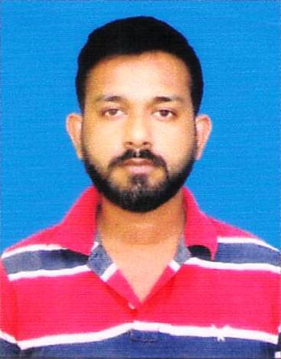**UDDALAK SARKAR**

ADD. : South Jitpur, Alipurduar.

PIN : 736123.

Mobile: **+91 7001870573**

***Career Objective:***

* To be associated with an organization that provides me an opportunity to show my skills, improve my knowledge with the latest trends and to be in the team that works dynamically towards the growth of the organization.

**EDUCATION QUALIFICATION**

|  |  |  |  |  |
| --- | --- | --- | --- | --- |
| **Sl. No** | **Examination Passed** | **Board / University** | **Year of Passing** | **% of Marks** |
| 1 | Madhyamik | WBBSE | 2005 | 58 |
| 2 | Higher Secondary | WBBHSE | 2007 | 41 |
| 3 | Graduation | NBU | 2010 | 41 |

**Technical Qualification**

|  |  |  |
| --- | --- | --- |
| **Sl. No.** | **Name of the Course** | **Name of the Institute** |
| 1 | **Diploma in Computer (DFAS)** | **Alipurduar Youth Computer Training Centre** |

**Experience**

* As a Customer Relationship Officer at Ujjivan Small Finance Bank since 10th April, 2018 to 29th February, 2020.
* As a Recovery Collector at HDFC Bank under 3rd Party Agency (BOLD) since 15th March, 2020 to 30th October.
* As a Collection and Recovery Officer at Jana Small Finance Bank since 25th November, 2020 to 31st March, 2022.
* As a Area Collection and Connect Manager at Jana Small Finance Bank since 6th April, 2022 to Continue.

**Contd.Page-2**

**Page – 2**

**Profile Summary**

* **Hard working, self-Motivated, Punctual and positive Attitude.**
* **A strong Motivational and Leadership skills.**

**Personal Information**

NAME : **UDDALAK SARKAR**

FATHER’S NAME : Pijush Kanti Sarkar

DATE OF BIRTH : 03.06.1989

GENDER : Male.

PERMANENT ADDRESS : Vill. – South Jitpur, P.O.- Bholardabri

P.S. & Dist.- Alipurduar, PIN- 736123

LANGUAGES KNOWN : Bengali, Hindi & English.

RELIGION : Hinduism.

NATIONALITY : Indian.

MARITAL STATUS : Unmarried.

CONTACT : **+91 7001870573**

E-mail : uddalaksarkar567@gmail.com

**Declaration**

I hereby declare that the above statements are true to the best of my knowledge and belief.

Date : _______________________

Place : Alipurduar Signature