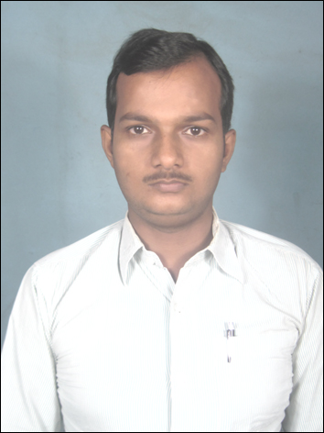
CURRICULUM VITAE

SHAILESH KUMAR SINGH
Email:-shailesh.singh696@gmail.com At- Pachkhatiya ,PS+PO-Shahkund,
Contact No. – 9852125810, 09031548449 Dist- Bhagalpur
Bihar - 813108

CAREER OBJECTIVE:

Seeking an opportunity to utilize my skills, potential to exploit my capabilities by working towards the growth of the organization while being resourceful and innovative.

EDUCATIONAL QUALIFICATION:
- Post Graduat(M.A) - (2012-2014)
BHARTIYA SHIKSHA PARISHAD UTTAR PRADESH (LUCKNOW)
Distance Education System
With 71%

- Graduation(B.A.) - (2010-2012)
BHARTIYA SHIKSHA PARISHAD UTTAR PRADESH (LUCKNOW)
Distance Education System
With 66.86%

- Intermediate(I.Sc) - (2007)
SINGHBHUM COLLEGE CHANDIL,
J.A.C RANCHI
(science with mathematics,).
With 48%
- Standard X - (2005)
S.S. HIGH SCHOOL, CHANDIL
J.A.C RANCHI
with 61 %.
TECHNICAL QUALIFICATION:

- Diploma in computer Application from Multi-Tech
- Call Smart traning from S.T.G
- Advance Diploma in graphics T designing from B.I.S.
- Diploma in Agricultural Extension Services For Input Dealers From MANAGE

COMPUTER SKILLS:
Operating System : Windows2003/XP/Vista
Software : MS DOS, Word Pad, Note Pad, MS Paint, MS
Office, Adobe Photoshop, Adobe Illustrator ,
Adobe Premiere Pro ,Audio editing ,Corel Draw ,
Micro Media Flash (2d Animation) , Toon Boom Studio
Hardware : Hardware Maintenance, Trouble Shooting
Other : Internet, Installing operating systems & various
Software in computer.
Typing : English & Hindi
ACHEIVEMENTS:
- Received a certificate for wining Second prize in Hindi speech of Pollution
- Won prizes in a quiz organized by B.I.S.T, Jamshedpur
- Participated and won prizes in Computer & other quiz contests.
- Won Awards in Cricket Tournaments.
EXPERIENCE:
Job Details
- Worked with Jamshedpur
- Airtel prepaid Csr (AEGIS PVT. LTD)(Fab.-2008 To Nov.2009)
Designation :- CSR
Rolls and Responsibility
- Sales Marketing
- Customer Support
- Customer Handing
- Solve problem for Customer
- Tata Tele Services Sales Executive(Jan-2010 To Dec.2011)
Designation :- Sales Executive
Rolls and Responsility :-
- Sales marketing
- Vist To company and Sales product
- Tale lead for Company and Given presentation
- Real Estate Jamshedpur (Avish Group)(March-2012 To Nov-2012)
Designation :- Unit Manager
Rolls and Responsibility
- Sales Marketing Real Estate
- Customer Handling
- Prayag Group (Sep.2012To Oct 2013)
Division :- Life insurance
Designation :- Asst Sales Executive
Rolls and Responsibility :-
- Sales Marketing life insurance
- Customer Handling
- Presentation of policy
- Nisaan Venture Pvt Ltd Bhagalpur (02 Aug2021 to oct2022)
Designation :- Area Business Manager
Division :- Business Devloapment
Rolls and Responsility :-
- Vist To company and Sales product
- Visit To Distributor and Discuss to Led Product in Market

- Raama Business Pvt Ltd Bhagalpur(01 Nov2022 To 10 March 2023)
Designation :- Asst Sales Executive
Division :- Finance and Collection Loan Repayment in Client

PERSONAL SKILLS:

Willingness to learn, optimistic, team spirit, energetic, hard worker, committed to job, behavior of getting something good from every one and implement them in the life

PERSONAL PROFILE:

Name : Shailesh Kumar Singh
Date of Birth : 26th june 1988
Father’s Name : Shri Shiv Shankar Pd. Singh
Nationality : Indian
Hobbies : Playing Computer Games, Searching Biography of Personalities
over the Internet & Listening to soft and inspirational Songs.
LANGUAGE EFFICIENCY:

Sn | Language | Speaking | Reading | Writing | Understanding
1. | English | Yes | Yes | Yes | Yes
2. | Hindi | Yes | Yes | Yes | Yes
3. | Bengali | Yes | No | No | Yes
4. | Bhojpuri | Yes | Yes | Yes | Yes

I hereby affirm that all the information given above is true to best of my knowledge.

Date:- .…………

Place: Shahkund (Shailesh Singh)

