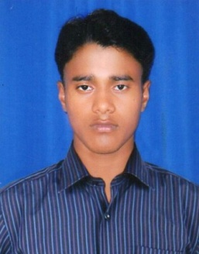
curriculum vitae

JAYANTA KUMAR NAYAK
Mobile no: +91 8337979145
Email id: jayanta07.nayak@gmail.com

Career Objective:

- To get associated with a firm which offers challenging job with a contributory environment and seeks innovative changes with the competitive market
- I wish to dedicate myself towards the improvement of the organization and work for complex satisfaction by utilizing my interpersonal skills and technical knowledge.

Academic Qualification:

Discipline | Board /University | School/College | Year  of Passing | %
Diploma in Electrical | SCTE&VT, Odisha | Satya Sai School of Diploma, Balasore | 2018 | 69.33%
ITI (Electrical) | SCTE&VT, Odisha | DAS ITI ,Balasore | 2014 | 70.71%
10th | Higher Secondary Education (H.S.E.),Odisha | Sahada High School ,Balasore | 2012 | 51.33%

Strength:

- Self confident & dedicated towards work.
- Work in a team with great enthusiasm.
- Adaptive towards every situation.

Professional Training:

- I have done Post Graduate Diploma in Computer Application (PGDCA) at PIIT Computer institution, Balasore.

EXPERINCE:

- 2 Years’ Experience in Cash Management service in WRITER BUSSINESS SERVICES PVT LTD.

HOBBIES:

- Searching Internet
- Listening Music

Personal Details:

Name : Jayanta Kumar nayak
DOB : 17th March 1997
Present Residence : C/o- Manmatha Nayak
At/Po- Ranasahi
Via - Sunhat
Dist - Balasore
Material Status : Single
Gender : Male
Language : Odia, Hindi & English

Declaration

Declaration:

I do hereby declare that the above mentioned information is correct to my knowledge and I bear the responsibility for the correctness of the above-mentioned particulars.

Date: - Jayanta Kumar Nayak

