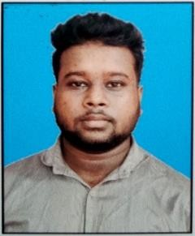RESUME

# AKASHDIP SARDAR

**[akashdip1334@gmail.com](mailto:akashdip1334@gmail.com)9064231334**

## *OBJECTIVE:*

* Seeking a career that is more innovative and interesting and a job that gives me opportunities to learn and strengths in conjunction with company goals andobjectives.

## *PROFESSIONAL QUALIFICATION:*

|  |  |  |  |
| --- | --- | --- | --- |
| SECONDARY | ALL SUBJECTS | WBBSE | 61.72% |
| HIGHER SECONDARY | COMMERCE | WBCHSE | 73.4% |
| B.COM(HONOURS) | ACCOUNTS & FINANCE | WBSU | 62.98% |

***COMPUTER SKILLS:***

Office Package – MS Word, MS PowerPoint, MS Excel Opperating System – Windows XP, Windows7, Windows 8,10,11

Editing Tools- Adobe Photoshop, Adobe Reader

Knowledge in Tally ERP

## *EXPERIENCE:*

* 01.01.2022 to Till Now as a Front Office Executive at Hotel Sonar Bangla, Taki

## *HOBBIES:*

* SurfingInternet
* Music
* Traveling

## *STRENGTH:*

* Open for learning, quick graspingpower.
* Co-operatingattitude.
* Team managingqulity.
* Ability to Work Smoothly inPressure
* Easily Adaptable NewAtmosphere

## *PERSONAL PROFILE:*

NAME : AKASHDIPSARDAR

FATHER’SNAME : GOPAL CHANDRA SARDAR DATEOFBIRTH : 22/12/1998

LANGUAGEKNOWN : BENGALI, ENGLISH, HINDI MARITALSTATUS : UNMARRIED NATIONALITY : INDIAN

RELIGION : HINDU

CATEGORY : SC

SEX : MALE

Place : BASIRHAT

Date: AkashdipSardar