CURRICULUM VITAE
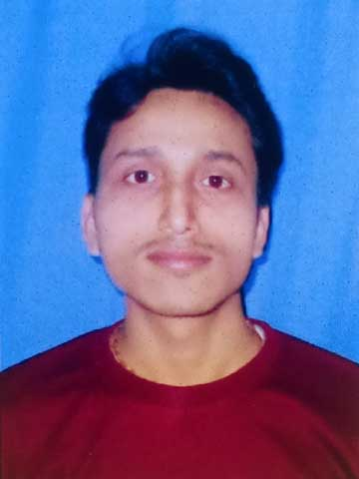
- NAME : NAROTTAM SAHA
- FATHER’S NAME : NITYANANDA SAHA
- MOTHER’S NAME : SHIPRA RANI SAHA
- ADDRESS : VILL- BHANUKUMARI GANDHI PARA
P.O+P.S- BAKSHIRHAT
DIST- COOCHBEHAR
PIN- 736131
- DATE OF BIRTH : 12/11/1992
- RELIGION : HINDU
- GENDER : MALE
- LANGUAGE KNOWN : BENGALI,ENGLISH,HINDI
- CONTACT NO. : 9734810888/8597955388
- E-MAIL : narottamsaha1000@gmail.com

- CAREER OBJECT: To achieve a challenging position in the industry and to use my technical communication and interpersonal skill for the growth of organization.

- EDUCATIONAL QUALIFICATION :
QUALIFICATION | BOARD/UNIVERSITY | DEPARTMENT | YEAR | MARKS | PERCENTAGE
MADHYAMIK (MP) | WBBSE | ARTS | 2008 | 579 | 72.37%
HIGHER SECONDARY (HS) | WBCHSE | SCIENCE | 2011 | 283 | 56.6%
GRADUATION (B.A.) | NSOU | ENGLISH HONOURS | 2017 | 390 | 48.75%

- OTHER QUALIFICATION :
- DIPLOMA IN COMPUTER APPLICATION (DCA).
- WORKED AS DATA ENTRY OPERATOR UNDER DIFFERENT SCHEMES AT THE OFFICE OF THE ASSTT. DIRECTOR OF AGRICULTURE TUFANGANJ-II BLOCK.

DECLARATION
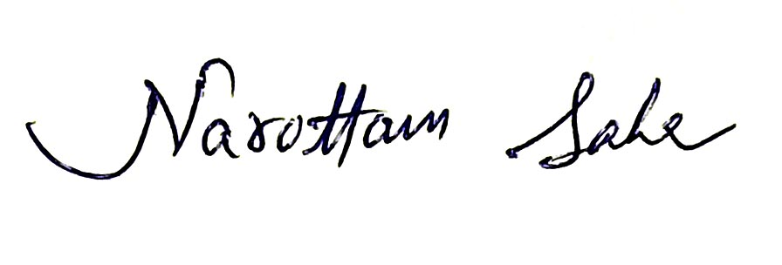
I’m. NAROTTAM SAHA hereby declares that all the statements made above are true to the best of my knowledge & belief & I’ll be liable to submit all the original documents to the concerned authority if & when required.
PLACE : __ ___
DATE : _____ SIGNATURE : __________________________

